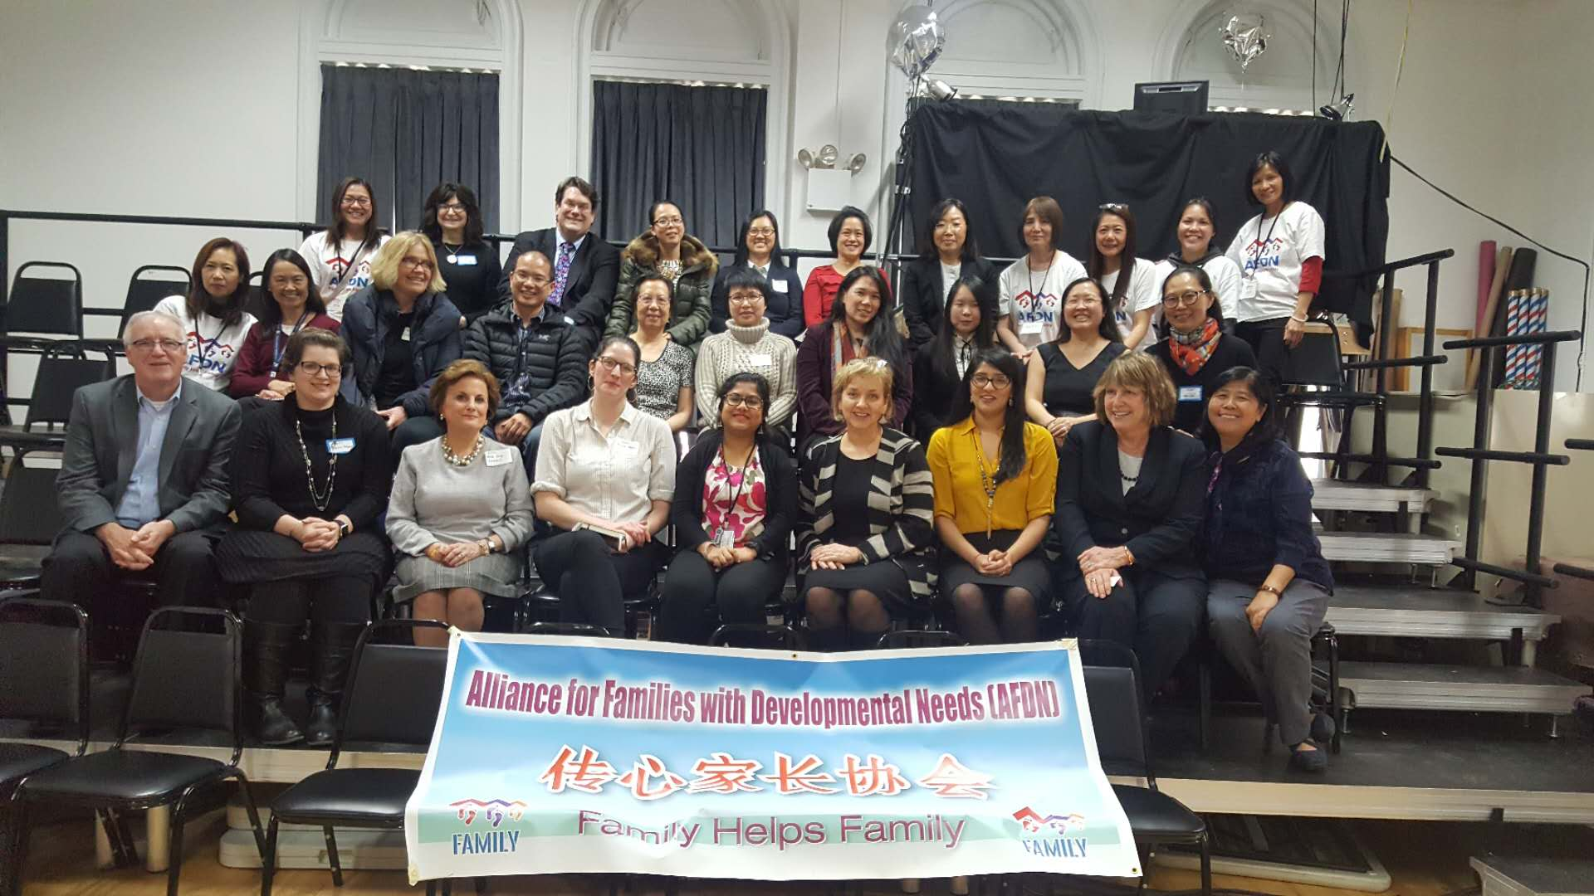

New York Chinese Parents

Community Forum
  - OPWDD Services and Transition to
  - Care Coordination Organizations/Health Homes (CCO/HH) II

  - Presenters:
  - Dr. JoAnn Lamphere, Deputy Commissioner,
  - Division of Person Centered Support at OPWDD
  - Dianne Henk, Director of Workforce Transformation, OPWDD
  - Hirah Mir, Project Assistant in Workforce Transformation, OPWDD

University Settlement Society of New York - Speyer Hall
New York City Chinatown
March 12, 2018
Table of Contents

- About the Forum
- Coordinating Parties
- Special Guests
- Acknowledgement
- Agenda of the Forum
- Summary of OPWDD Presentations
- Summary of Community and Parents’ Feedback on OPWDD Presentations
- Summary of Parents’ Questions and OPWDD Officials’ Answers
- AFDN Parents’ Remarks
- Conclusion and Next Step
- Appendix I: Press Coverage
- Appendix II: Selected Photos
- Appendix III: Deputy Commissioner Presentation PPTs and the Chinese translated notes
- Appendix IV: Luncheon Participants List
- Appendix V: Flyer of the Forum

About the Forum

Background
The first New York Chinese Parents Community Forum on December 4, 2017 was a historical landmark that Deputy Commissioner (Division of Person Centered Support) Dr. JoAnn Lamphere of NYS OPWDD’s (Office of People with Developmental Disabilities) met with 160 Chinese parents having children with developmental disabilities in the NYC Chinatown. The great success of the forum was the outcome of tremendous supports and collective efforts from numerous parents, individual advocates, community organizations, social service agencies and New York State agencies.
In the December forum, OPWDD Community Service Administrator Ms. Ellen Bleckman had outlined the existing OPWDD service delivery system. Deputy Commissioner Dr. Lamphere had described in details on the forthcoming changes of the OPWDD service delivery system from MSCs to CCOs. Dr. Lamphere spent a great deal of time hearing parents’ questions, concerns and testimonies relating to their difficulties and dilemmas in caregiving and navigating the service delivery system. She described the forum as an eyeopener for her and she felt parents’ stories were compelling to her. She brought the stories back to Albany and shared with OPWDD higher officials.
The first dialogue between Chinese parents and OPWDD officials achieved several outcomes. The forum increased parents’ knowledge on the OPWDD transitions to Care Coordination Organizations/Health Home (CCOs/HH). Parents were concerned about the impacts of the transitions on their children with special service needs and their families, as well as the challenges they encountered in navigating the existing service delivery system. These challenges include, but not limited to, experiences as follows:
- Problems and obstacles in applying, accessing and obtaining OPWDD funded services.
  - accessibility and lacking knowledge about OPWDD services
  - long process of application and waiting
- Problems and obstacles in obtaining cultural and linguistic competent services due to cultural segregation and language barriers.
  - lack of cultural and linguistic competence resources and professional services in the community
- Gaps between service capacities and real needs of the Chinese I/DD community
  - limited capacities of community service providers
  - unknown number of children/individuals not identified with I/DD
- Worries and uncertainties for losing Chinese focused local service points after the transitions to CCOs/HH

Dialogue will not stop, it continues. Deputy Commission Dr. Lamphere sincerely expressed that she would return to NYC Chinatown to meet our parents again. And, she did. Dr. Lamphere returned in March 12 of 2018. She also brought along her colleagues Ms. Dianne Henk and Ms. Hirah Mir from Workforce Transformation, to this New York Chinese Parents Community Forum II.

Purposes of the Forum II
- To continue dialogues between OPWDD and Chinese I/DD community.
- OPWDD to update the progress of transitions to CCOs.
- OPWDD to respond to and address parents’ questions and concerns raised in the Forum I.
- To enable Chinese parents to increase knowledge and clarify their confusion on the transitions to CCOs.
- Chinese parents to hear OPWDD’s responses and learn about the agency’s plans to address their questions and concerns raised in the Forum I.
The Forum
Over 160 Chinese parents and caregivers were present in the Forum held on March 12. About half of attendees had participated in the December event and half of them were first time participants. An estimate of over 200 parents and caregivers in total had been involved in the two forums. However, there were much more parents and caregivers in the community that had not have the chance to meet the OPWDD Deputy Commissioner and officials from Albany.
In the second forum, only one parent expressed that she was fluent in English and had no problem navigated the OPWDD service delivery system. Half of the participants expressed that they speak some English, but still encounter many problems handling their children’s application and use of OPWDD services. Another half expressed that they speak very little or no English. They have a great deal of problems initiating OPWDD applications and use of OPWDD funded services.
In the first session of the forum, Dr. Lamphere gave an update on the transitions of the new CCOs. Ms. Henk and Ms. Mir provided details in community practice of the CCOs and the standards of cultural competence practice of the care managers. Parents paid serious attention in the presentations. More than ten (10) parents had raised questions and concerns regarding the new changes from MSCs to CCOs.
Dr. Lamphere’s presentation PPT slides are enclosed in the Appendix of this report. Contents of the presentations are summarized in the “Summary of OPWDD Presentations” section of this report.
Coordinating Parties

Lead Sponsor:
Alliance for Families with Developmental Needs (AFDN)

Co-Sponsors:
University Settlement Society of New York
Charles B. Wang Community Health Center
Chinese American Planning Council Queens Community Services
C.A.R.E.S. NYC (Caring for Individuals with Special Needs and their Families)
GHO (General Human Outreach)

Supporting Agency:
Legal Services NYC

Welcome our Special Guests
Thank for Your Presence to Support the Forum
Advance Care Alliance (ACA)
Mr. Jay Nagy (CEO)
Mr. Pter Pierri, (Consultant)

Care Design
Mr. James Moran (CEO)

C.A.R.E.S
Dr. Leah Lax (Program Director)

CPC (Chinese Planning Council)
Mr. Wayne Ho (CEO)

NYS Developmental Disability Planning Council (DDPC)
Ms. Sheila Carey (Director)
Dr. Jacqueline Hynes (Diversity and Inclusion Program Specialist)
Jessica Pidgeon (Staff)
Nabila Ibrahim (Staff)

Acknowledgment
First and foremost, we would like to express our gratitude to OPWDD Deputy Commissioner Dr. JoAnn Lamphere and Director of Workforce Transformation Ms. Dianne Henk and her staff Ms. Hirah Mir, for making the time to attend the forum.
We would like to thank University Settlement for hosting the forum again in the Speyer Hall of the organization.
We would like to thank Nyuksiem Yap (Sim Looi), President of AFDN, and AFDN committee members Angie Zahida Ahmed, Fiona Shu Huan Ho Xu, Debbie Wai Ching Chan and June Siew Ling Lum for your passion, vision and leadership in organizing and mobilizing the hundreds of NYC caregivers.
We would like to thank Dr. Rhoda Wong for your tireless leadership, selflessness, incredible vision, wisdom, tremendous support in order to ensure our caregivers’ voices in the community can be heard.
We would like to thank the program planning and coordinating team Ms. Eva Wong, Ms. Michelle Liu, Dr. Sherry Huang, Mr. Nelson Mar, Ms. Kathy Li and Ms. Pat Liu for their partnership, ongoing support to community caregivers and for handling the logistics of the forum.
We would like to thank C.A.R.E.S. NYC for providing knowledgeable staff for on-site interpretation at the forum.
We would like to thank Charles B. Wang Community Health Center, Chinese Planning Council (CPC) and General Human Outreach (GHO) for sponsoring the luncheon for forum organizers and our guests.

Agenda of the Forum
- Welcoming
- OPWDD Presentations by –
Dr. JoAnn Lamphere
Ms. Dianne Henk
Ms. Hirah Mir
Topics:
  - New development on transitions to CCOs
  - OPWDD Responses to concerns/questions raised in the December forum regarding current service delivery and also extend to transition
3. Questions and Answers
4. AFDN Parents’ Letter to Deputy Commissioner
5. Break and Networking
7. Luncheon Meeting

Summary of OPWDD Presentations
In the beginning of the forum, Dr. Lamphere talked about the OPWDD commitment to Chinese families and their children with developmental disabilities. In the December forum, she was shocked to learn so many Chinese parents had no knowledge on OPWWD and its services offered through Medicaid. Therefore, she wanted to make sure that the children with special needs will receive “person-centered” services. That means, when the needs change and services will change. It is to be flexible and easy to access. She also emphasized for OPWDD to provide a high-quality, outcomes-based system of supports that includes health and wellness of individuals receiving services.
Second, she reiterated that Health Home Managed Care will be implemented in July 2018. Medicaid Service Coordinators (MSCs) and the agency they are working in will join a new bigger organization called Care Coordination Organizations (CCOs). CCOs will work with individuals with special needs and their families to develop and manage a specialized person-centered service plan called the Life Plan, based on one’s needs. CCOs coordinate with other agencies and assure services in place to meet the special needs of individuals approved for OPWDD funded services.
There are six core service areas that CCOs will provide:
- Comprehensive Care Management
- Care Coordination and Health Promotion
- Comprehensive Transitional Care
- Referral to Community and Social Support Services
- Individual & Family Support
- Health Information Technology
Dr. Lamphere was very positive that changes in service coordination will not affect the services that individuals with development disability and their families are presently receiving.
CCOs transitions and structural changes seems going very rapidly, but it has been processing since June 2017. Six new Care Coordination Organizations (CCOs) were approved by OPWDD. The Chinese community-based agencies will join with the CCOs to make this a larger and more effective operation. Now, OPWDD is working to assure these CCOs will be able to implement exactly what they had written in their application and be ready to start services for individuals with DD. For example, if they have staff people to help translate information and forms into Chinese, they need to show OPWDD what these materials are. If they succeed in showing the proof, then, these CCOs will be ready to start serving the community on July 1.
Summary of Parents’ Feedback on OPWDD Presentations
Question # 1
Will OPWDD do more proactive local outreach to the community, particularly to the non-English and Chinese-speaking populations?
OPWDD Answers (by Ms. Mir)
This is a very important question related to cultural competence. The Deputy Commissioner’s presence in the last December forum was in fact the OPWDD’s first step to begin communications between Chinese parents and OPWDD. The dialogue will continue. The answer for this question is “Yes.” JoAnn will continue to be more proactive to engage with non-English communities through forums and other activities. We will continue to talk about how to communicate even better and better.
Parents’ post-forum follow up questions and feedback
AFDN parents appreciate the Deputy Commissioner’s openness and her continuous dialogues with the Chinese community. We would like to see more tangible and comprehensive plans how OPWDD as well as CCOs will outreach to families in our community. For example, we suggest that OPWDD will consider hiring or designating a bilingual worker to be responsible for community outreach. On one hand, this worker will outreach to schools, health care and mental health clinics, general social services agencies. S/he can attend community meetings to provide training and sharing OPWDD information with professionals serving the Chinese community. On the other hand, this designated person will develop better understanding of the needs of the Asian I/DD community and bring back this information to OPWDD.
In response to the concerns of accessibility of OPWDD services and outreach that raised in the first Chinese Parents’ Forum, the Asian Health and Social Service Council (AHSSC) plans to organize a conference on the “service delivery system and resources for people with developmental needs and families” for health and social service professionals working in the Asian community in late October 2018. We hope that OPWDD and CCOs will be present and support this conference.

Question # 2
What are OPWDD’s plans for developing a culturally and linguistically competent workforce (beyond using language line to achieve language access) to interface with families?
OPWDD Answers (by Ms. Mir, Ms. Henk and Dr. Lamphere)
Ms. Mir: This question is important because it highlights the engagement in different communities require more than just translating. The first step for OPWDD is to learn what are the needs in the community and understand what kinds of outreach activities to engage the community. OPWDD is committed to closely work with Dr. Jacqueline Hayes of the NYSDDPC Diversity and Inclusion Program Specialist in such areas. We are still in the very early stage doing assessment on the needs of the community and will continue to do research and assessment on the community needs. For example, the December Forum report submitted by AFDN was very useful for us to understand more of individual with special needs and their families. We will think about possible plans and proposals that could make changes and address to the needs and problems in the community. We started an Initiative and partnership with DDPC and other agencies to work on these concerns. This is a priority that we are working on at this time.
Ms. Henk: In the new system, the CCOs are required to complete more tasks. OPWDD will help to train the current MSCs to transition to be new care coordinators. New CCOs will be trained on how to work more effectively helping individuals with developmental service needs and their families. There are 10 areas that new CCOs are trained. One of the core area of the training is “Cultural Competence.” Ms. Henk defined cultural competence as follows:
The MSC had to understand your language, your preferences, some of your traditions and choices that are important to you and the person who use the services. All the MSCs becoming CCOs are required to learn about the people they are going to serve.
Dr. Lamphere talked about an example of cultural competence. She stated that to understand how people come to know they need services for a family member who has intellectual or developmental disabilities services. She recalled learning stories in the December forum how oftentimes children were not diagnosed in medical offices. Sometimes, their needs were not identified in schools. And, sometimes parents were either afraid of or embarrassed when they had a child with developmental disabilities. So, organization with cultural competence practices will be aware of these pressures and fears and do a better job of helping to meet those needs.
Parents’ post-forum follow up questions and feedback
Ms. Mir mentioned that OPWDD and DDPC started an Initiative to address the needs and problems of people with developmental needs and their families. AFDN parents would like to learn more about the Initiative, including the goals and objectives of the working team, issues being addressed in the team, working approaches and timeline for achieving goals and objectives.
Ms. Henk mentioned about the new CCOs are being trained in ten (10) areas. One of the core area of the training is “cultural competence.” AFDN parents are concerned how OPWDD will assure and evaluate the trained care coordinators/managers actually implement the cultural competence as well as the other nine core area in practice. Are there any measures to follow up or evaluate the trained worker for the quality and effectiveness of their cultural competence practices?

Question # 3
How will accountability be built for CCOs?
OPWDD Answers (by Dr. Lampherer)
Dr. Lamphere defined “accountability” as to make sure that services having been authorized are actually delivered. Use of an IT system is an easy way to work on that. NYS will be studying quality measures. The Department of Health and OPWDD will be collecting information about quality. After data are collected, they are not placed in the file cabinet. OPWDD will analyze the data and learn from the data to see how they can do better. On the other hand, they will have satisfaction survey conducted annually. And, these are the chances individuals and families receiving services to say what they really think. Some of this quality information will be published. So, families can choose where they want to go to receive services. Families will have more information and make choices for the person they care for.
Parents’ post-forum follow up questions and feedback
Dr. Lamphere mentioned the OPWDD and the Department of Health will collect data on quality of CCOs. AFDN hopes to learn more details of the data collection, including areas being surveyed, the sources and process of data collection. The analyzed findings of the collected data will really reflect both the positive as well as the negative outcomes of the new service delivery system. We also hope that the findings will be transparent to the I/DD community. The community will have chances to respond the findings. OPWDD/DOH/CCOs will be able to respond to public comments and recommendations. Quality assurance and improvement in service delivery are our real concerns.
Moreover, Dr. Lamphere mentioned about the annual satisfaction survey. Satisfaction survey is a good way that services recipients and families reflect their experiences in using services. AFDN parents want to know: Is the survey distributed by OPWDD or by CCOs to individuals receiving services or the families? Will the survey be translated into different languages that can be understood by non-English speakers?

Question # 4
Will there be a family advisory board or team formed to under the new system so that OPWDD can be kept informed and updated on quality and effectiveness of CCOs and programs?
OPWDD Answers (by Dr. Lamphere)
The answer is “yes.” The family advisory body is not to advise OPWDD but to advise the CCOs. So, they can operate better. Advisory board members are individual self-advocates and family members. The advisory board is especially important in these new care coordination organizations. The advisory board is a formalized way for family members to advise the leadership and board of directors to coordinate on emerging problems and emerging needs. CCOs are required to have Family Advisory Board. This requirement was added as a result of the public comment. It was family who worked on the original applications asked, “where is the role for me?”
Parents’ post-forum follow up questions and feedback
AFDN parents would like to obtain more information about the family advisory board. We need clarifications on the board’s purpose, function, structure, and role of individuals and family members. How an advisory board member contributes to the board and the operation of the CCO? Can a member bring up other parents’ complaints and recommendations to the board?

Question # 5
Will there be physical locations set up to serve families? Many parents from immigrant communities are most comfortable meeting in person.
OPWDD Answers (CCO representatives)
ACA: We are planning to have regional offices.
Care Design: In addition to planning of having regional offices. The current MSCs will continue to work and meet people in the agencies that they are working at now.
Parents’ post-forum follow up questions and feedback
AFDN parents want to know when and where the CCOs will open local offices to serve the community.
We know that the original MSCs will continue to use the physical space of the former agency to serve their clients in the first year. If so, how does the new CCO manage working teams in different locations (originated from different agencies) to maintain the same level of quality while delivering services to individuals using services and their families. How does the CCO manage to develop new organization and working culture while care coordinators continue working in the same space and environment?

Recommendations for OPWDD from NY Chinese Parents Community Forum I
- More outreach Work
- More resources to increase number of bilingual service coordinators
- More resources to increase overall cultural and linguistic competency of service providers
- Continue open dialogues with the Chinese community.
OPWDD Feedback on the Recommendations
As you can see, we are beginning to work on these recommendations. We do more outreach work. We are here today. For the second recommendation, you see the bilingual care coordinators are included in the new CCOs. For more resources to increase overall cultural and linguistic competency of service providers, I expect these will happen in the next few months and years. We will work together to make this happen.
Finally, to continue open dialogues with the Chinese community…This is absolutely the commitment of all of us in OPWDD.
Parents’ post-forum follow up questions and feedback
AFDN wants to thank Dr. Lamphere and her colleagues’ sincerity and commitment to the Chinese I/DD community. We hope that we will continue to work together to address the issues that brought up in the forums. Hopefully, tangible and comprehensive plans will be developed to improve the community’s experiences in navigating the service delivery system for people with developmental needs.

Summary of Parents’ Questions and OPWDD Officials’ Answers
Question # 1
What is the new procedure for applying OPWDD services under the new Health Home model? At this time, parents receive supportive services from family support workers in the local agencies, before OPWDD funded services are approved. Family support workers assists parents throughout the application process. Under the new model, do family support workers in the community continue to or the new CCOs will assist the parents to apply for OPWDD services?
OPWDD Answers
Dr. Lamphere: The procedure for accessing OPWDD services through the Front Door will not change. The Front Door will continue to help you to determine Medicaid eligibility and figure out services that your family member is eligible for what. You can join a CCOs.
CCO representative: I think the question is about community worker. Up to this point. The contract for family support worker had no change. The existing services helping individuals with I/DD and families to apply for OPWDD services will continue. Current community agencies and CCOs may have combined co-responsibilities to support individuals and families.
Parents’ post-forum follow up questions and feedback
AFDN parents believe that family support workers play an important role in helping families to apply for and obtain OPWDD services. However, the family support workers in almost all agencies are extremely “overloaded.” One service provider told us that a family support worker in their agency has a caseload of 150. AFDN parents believe that this could be a reason to explain the prolonged waiting time for service application.
AFDN parents hope that OPWDD would increase resources and expand the existing contract to increase bilingual family support workers in local community agencies. In addition, the family support workers should have reasonable time to receive in-service trainings for updating knowledge in practice.

Question #2
Under the new HH model, do parents apply OPWDD services directly from a particular CCO. During transition period, do parents directly contact the CCO main office or they can walk in to any contracted agencies to request for care coordination services for their children with developmental disabilities?
OPWDD Answers: (by Dr. Lamphere)
For someone who is new to OPWDD services, they would go to the local DDRO, the regional office known as the Front Door. For someone who has services right now, you can expect to receive communication through your MSC this spring. And your MSC will detail and explain how to join a CCO. S/he will give you forms to fill out to make sure you are really joining the organization. Then, you understand what will be happening. Forms can be translated if necessary. The point is if you have services just in spring, your MSC will be reaching out to you.
Community agency should direct parents to the Front Door if they are new or direct them to the CCO. If the family happens to go to the agency… If the agency happens to know how services are authorized and coordinated, that agency would probably referred the individual to the Front Door if they need to be determined the eligibility and the CCO.
Ms. Henk added: OPWDD had prepared brochure, also translated into Chinese, to explain the new transition to CCOs.
Parents’ post-forum follow up questions and feedback
According to AFDN parents, going to Front Door is not the first step for applying OPWDD services. For the monolingual Chinese speaking parents, almost all go to community agencies asking for help from a family support worker. The family support worker will provide counseling for parents or caregivers regarding the steps for application. The first step is to look for agencies to do assessment and then prepare relevant documents. The bilingual family support worker helps the parents to make phone calls and schedule appointments for assessment particularly when parents do not speak English. This usually takes months before the parents can really go to Front Door to initiate the application.

The above question was not quite clear to AFDN parents. However, we have two different interpretations:
- The mother has not started but prepares to initiate the application process. If so, she was looking for family support worker in the community agency currently providing the application support services. Before this forum, parents were confused if CCOs would take up the role to support families to work through the application, as family support worker is doing now in the community agencies.
- The mother has started the application and her child has been determined eligible for OPWDD services. However, they still do not have MSC serving them at this time. If so, the question would be where does she go to request for care coordinators for her child after July 1. Can she go to any of the local CCO subcontracted agency or directly go to CCO main office?
According to many parents, they were told that all new requests or referrals for MSCs are pending at this time until further notice. AFDN parents ask when will CCOs start taking new cases and assign care coordinator for individuals recently approved for OPWDD services.
Ms. Henk mentioned about the brochure explaining the new transition to CCOs. AFDN parents read the Chinese version of the brochure. Translations in that brochure have been improved a great deal comparing to materials previously reviewed. Some terms used in the content are still misunderstood or not comprehend by the Chinese parents.

Question # 3
Currently, some local agencies in the Chinese community and their MSCs are overloaded and turn parents away. During transition, are the subcontracted agencies under the same CCO share caseloads? Will parents and their children receiving OPWDD services automatically transferred to another subcontracted agency under the same CCO.

OPWDD answers (by Dr. Lamphere)
We understand there can be waiting time to get services and what we want to achieve with the CCOs is to reduce that waiting time. Remember that care coordination is teamwork, not just one person.
Parents’ post-forum follow up questions and feedback
AFDN parents believe prolonged waiting time is caused by shortage of manpower. We would like to see OPWDD and CCOs will increase new resources to strengthen the existing manpower, including recruitment, training and career development. We strongly support to increase wages and hire higher quality workers.

Question # 4
During the transition period, do parents have the right to choose any particular subcontracted agencies to provide care coordination services? If the parents do not satisfy the services provided by one subcontracted agency, can s/he request to switch to another subcontractor within the same CCOs?
OPWDD Answers: (Dr. Lamphere)
This is a very good question. Families have a choice of which CCO they would like to join. We have two distinguished among the three in New York are here right now. So, there are 2 very committed to your community sitting right here in the room. You will be possible to have a choice of your coordinator. If you are happy with your MSC and your MSC joins one of these agencies. Then, the agency may be the one you want to go for.
Parents’ post-forum follow up questions and feedback
Annual satisfaction survey was mentioned in earlier section of this report. AFDN parents ask where these parents can go to get better quality services if they do not satisfy the services provided by each of all CCOs. In reality, there are very limited choices of CCOs.

Question # 5
I want to know what is “transition to Managed Care.” (PPT p. 1) How long will it take for the transition.
Now, I have a situation. I have to give up my managed care Medicaid (Affinity) and enrolled into straight Medicaid, in order to have my child receiving OPWDD services. During this transitional period, should I keep my current managed care insurance plan. Or, should I give it up to apply for Medicaid.
OPWDD Answers (Dr. Lamphere)
In New York State, there are about 23,000 individuals who have intellectual or developmental disability now have managed care to cover their acute care services. And, there is an organization called a FIDA IDD, which is a managed care organization that serve people with both Medicare and Medicaid coverage. So, managed care is not new in our system.
We plan to have managed care grow in the next four years. First will be volunteer and once there are enough information that is working well. It will become a mandatory. But you can expect that change over the next 4 or 5 years.
For the second part of the question, I would talk to the parent personally.
Parents’ post-forum follow up questions and feedback
Now, individuals eligible for OPWDD services have to obtain waiver and apply for straight Medicaid in order to receive OPWDD approved services. AFDN parents want to know if individuals having developmental needs with managed care Medicaid will receive OPWDD approved services in future? How soon will it take?

Question # 6
I hope that the future care coordinators will help to coordinate dental services. In addition, I hope that Asian unit within the CCOs or local offices in the Chinese community will have Chinese speaking receptionist or Chinese-speaking phone line for families of recipients.

OPWDD Answers (by CCO representatives)

We are going to preserve the local offices in the community. We will have Chinese-speaking staff for the families.

Parents’ post-forum follow up questions and feedback
AFDN parents would like to know where will the local CCO offices be located? How many? Will Chinese-speaking families living outside the traditional Chinese neighborhoods receive bilingual care coordination services?

Question # 7
I want to ask question about the PPT Slide # 6 of the Deputy Commissioner’s presentation. There are a list of questions asking if changes in service coordination will affect me. I felt that all questions are positive. They directed me to think optimistically. However, I am not sure if any situations not listed in the slide will happen in future and cause great impact on our child and the family. This particularly affect the Chinese families very much, as we do not speak English and strongly require cultural and linguistic competence services. Anyway, CCOs is a new program. Conservatively speaking, during transition, there must be some kinds of unexpected challenges, we hope that either OPWDD and CCOs, based on the principle of “people first,” protect the benefits of the individuals and their families that are receiving OPWDD funded services.
OPWDD responses (Ms. Henk)
This is a good point. Person-centeredness is the most important value of all the service coordination that we are going to be supporting. Most important now, will remain to the transitions to CCOs. So, it’s all about connecting the people who need services and helping them. It’s not about the system. It’s about them. So, it’s not easy to do that, but that’s the goal. That’s what our standard is. Person-centeredness is number 1. For the MSC, for the training and for the system as a whole.
Parents’ post-forum follow up questions and feedback
AFDN parents would like to know if there is any contingency plan to deal with any unpredictable circumstances occurred during the implementation of the new CCOs?

Question # 8
What is OPWDD’s role in assisting Chinese parents to assure that the new CCOs would take seriously the unique needs of Chinese families in terms of cultural and linguistic competencies? For example, to secure a strong manpower of bi-lingual care coordinators within the organization? Will Chinese families/individuals with I/DD have an opportunity to meet with the new CCOs to listen to parents’ directly re: unique needs and challenges before July 1, 2018.
OPWDD Answers (Dr. Lamphere)
That’s an important question. I am going to answer the question in a couple of different ways. First, when the State design CCOs, one of the requirements in the CCO application is to demonstrate cultural competency. The gentleman here is from the care coordination organizations are here because of their commitment to you. There are here to learn. Therefore, they can design services that work for you. And giving the caliber of CCO leaders in NY. I am sure that they will be in open door for structure meetings to continue to learn about the Asian community.
Parents’ post-forum follow up questions and feedback
CCOs plan to maintain Chinese-speaking manpower in their organizations. AFDN parents want to know what disciplines of the professionals and workers will be included? Are they care coordinators, nurses, or other supporting staff? What are their roles and functions in the CCOs?

Question # 9
Deputy commissioner had mentioned that more bilingual services will be in place for our Chinese families and parents. I have a situation to ask the Deputy Commissioner. My child was diagnosed ADS at 21 months old. I live in the Bronx. As I know, there is no agency providing bilingual services helping me to apply for OPWDD services for my child. I want to know if the new CCOs will help me to get bilingual services in my area. It has been 9-months without services…My child is now 30 months old. I want to know, under the new CCOs, if it’s possible and for how many months my child would obtain OPWDD services from bilingual providers.
OPWDD Answers (by Dr. Lamphere)
One of the shocking things we learned in the forum was how long it takes together the families to get services. I am sure that is something that we are going to be working on with the CCOs to diminish the time that it takes to get services.
Parents’ post-forum follow up questions and feedback
This question is similar to other questions listed above. AFDN parents have no follow up questions or feedback.

Question # 10
My child has just been determined to be eligible for OPWDD services. I don’t know how to obtain the funded services. His Medicaid is pending. I believe Medicaid would have been approved in July. So, under the new CCOs, how this process will move on.
On the other hand, I hope the new CCOs will increase more bilingual service capacities to the Chinese community. Currently Chinese agencies has too many cases. The mainstream services agencies kept telling us there they did not have the manpower to help us. Therefore, things were delayed, until my oldest son who speaks English helped me to search for an agency in Brooklyn to start the application.
OPWDD Answers (Dr. Lamphere)
First, it is important to contact the OPWDD DDRO regional office. Last time, we were here, there was a representative from that office. We should make sure that you are hopped up with the DDRO.
Follow up question:
Do DDRO staff speak the parents’ language? How do I communicate with the DDRO representatives if they do not speak Chinese?
Chinese parents who does not speak English do not know what to do in the first moment when they heard people only speaking English on the other side of the phone. They may just hang up the phone
OPWDD Answers (Dr. Lamphere and Ms. Henk)
We have translation services in DDRO. When you call, we can do it automatically. I don’t know the quality of the translation.
I can just say we have the system in place. When you call, they don’t speak the language. They can identify what language you speak, you may have to wait for a few moments. They can put you on hold and get a translator to join on the call to handle the conversation. I encourage people here when you call, not to hang up. Press through, get a person. And, you can say, “I need Chinese translation.” We had had instructions at all the OPWDD offices.
Follow up question:
We hope that OPWDD hires bilingual (Chinese) staff and places workers in DDROs in future.
OPWDD Answers (Ms. Henk)
I am certainly that I am not authorized to make that decision. But, as we continue our relationship with you all, we are going to work toward that. If they promised and we are able to justify the need. That would be great. I don’t know. We have to start somewhere. This is a good beginning.
Parents’ post-forum follow up questions and feedback
AFDN parents are pleased to work with OPWDD to explore and determine the need for hiring bilingual employees in OPWDD. We can look into the Census and the statistics of Asian Population in New York City. In fact, there are many bilingual employees in all different agencies in the NYC government.

Question # 11
First, I want to tell I am a shy person. I am nervous speaking in the public. But, for the sake of my child, I get the courage to speak here. I have a question about my MSC. I am satisfied with the services she provides. However, if my MSC is not able to transition to the new CCOs, will I lose my care coordination services? If so, who will help me to sustain my services and transition to the new CCOs.
OPWDD Answers:
That’s a very good question. She should ask her MSC, which CCO the MSC is planning to join. If an individual MSC is not joining any new CCOs, the individual and the family will get a new care coordinator. We can also ask, after this meeting, what agency employs the MSC. We can find out which CCO that agency had joined. It is very important for the MSC to come along with the agency. Otherwise, he or she will be out of job to do MSC work. It will threaten the continuity of services of the people who she was supporting. So, we will be encouraging her to have an open-mind and good choice and take a good risk moving forward.
Parents’ post-forum follow up questions and feedback
AFDN parents do not have follow up questions or feedback for this concern.

Question # 12
What are the ten areas that are most important for every MSC?
OPWDD Answers
The ten areas are:
- Person Centeredness and Communication
- Relationship Building and Communication within the CCO
- Community Orientation
- Cultural Competency
- Understand all aspect of health, wellness and medical terms
- Understand new models of support and health care trends
- Training of professional ethics
- Quality improvement
- Information technology
- Proper documentation and confidentiality
Parents’ post-forum follow up questions and feedback
AFDN parents are concerned how OPWDD will monitor the care coordinators to achieve the goals of the ten (10) areas in practice? How to ensure the practice of each care coordinators will be good with same level of quality?
AFDN parents suggest that care coordinators will receive in-service trainings periodically to remain current of their knowledge and skills in service delivery.
Moreover, we hope that OPWDD, DDPC or CCOs will consider to compile a resource and service directory for care coordinators as reference in practice. The directory should include lists of service providers on different disciplines in the five boroughs. The directory should be updated annually. Ideally, the lists should also include linguistic competence of the providers.
We also hope that OPWDD and CCOs will advocate service providers of different disciplines to implement cultural and linguistic competence practices.

Remarks by AFDN parents to the Deputy Commissioner of OPWDD
Deputy Commission 副局長:
Sim: My name is Sim Looi. I am the President of AFDN. I have two sons aged 21 and 17, both diagnosed with autism spectrum disorder at young age.

Katie: My name is Xiao Feng Liu. I am an AFDN parent member. I have two sons and a girl who are triplets. They are all 15.

Both (Sim-Chinese and Katie-English): All our children are receiving OPWDD services.

Today, we are grateful to have the OPWDD Deputy Commissioner Ms. JoAnn Lamphere and her colleagues to return to our community and bring back answers to our challenges and appeals mentioned in the forum last December. Since we only have 2 hours, we understand that we are not able to address all the concerns and many unanticipated challenges that we will encounter during the transition to CCOs.

今天，我們很高興OPWDD的副局長重臨我們的社區，對我們去年十二月舉辦的論壇中所提出的問題帶來回應。今天，我們只有兩個小時，我們明白是沒有辦法針對所有問題及CCO過渡期中難以估計的挑戰作出討論。

Our parents had asked many questions and expressed their concerns and we sincerely believe that Dr. Lamphere and OPWDD officials hear our voices. At the end, AFDN parents want to conclude this forum with the followings remarks:

我們的家長已發問及表達他們的關注，我們很認真地相信副局長和她的同事們已聽見我們的聲音。最後，傳心家長會作出以下的總結:
- First, we want to revisit the concern of cultural and linguistic competence.
首先, 我們想重提适合我們語言文化背景的服務的議題
  - Cultural competency is more than linguistic competency. In our community, language line doesn’t work out to help our parents. Lost in translation occurs when the translator does not have any knowledge about the developmental disability community.
适合文化背景是遠超過單單語言能力。翻译熱線在我們的社區裡，對家長來說並不管用。當翻译員缺乏對發展障礙群體的認識時，翻译出來的東西就會失去原本的意義。
  - Lost in translation also occurs in many brochures and booklets published by OPWDD and other government agencies, including Department of Education. We understand that OPWDD made tremendous efforts to provide translated materials to people with developmental disabilities and their families in the Chinese community. Unfortunately, many parents have difficulties understanding or misunderstanding meanings of the translated materials. We hope that OPWDD would address the concerns on the quality of translation in the printed materials.
許多OPWDD出版的小册子或手册的翻譯失去原本的意義，我們知道OPWDD已經很用心提供翻譯資料給發展障礙人士及家長， 然而，很多家長覺得有困難理解或誤解這些翻譯資料。
  - Moreover, we hope that Chinese parents would be able to fill out and submit OPWDD forms and documents in the language they choose in future. We asked if the forms can be printed in Chinese.
再者，我們希望華人家長在未來可以用自已的選擇的語言文字填寫OPWDD的表格及文件。我們希望可以以中文印制。

- Secondly, for long time, there were inadequate bilingual Medicaid Service Coordinators as well as OPWDD funded direct service workers serving the Chinese community. Many parents experienced long waiting time before services are eventually in place. In the new system, how CCOs help Chinese families to secure the OPWDD approved direct services? Will OPWDD plan to invest and put in more resources to help the Chinese community to recruit, hire, and train more bilingual direct service providers? In what way OPWDD would extend the measures to monitor community providers in recruiting quality workers and providing effective trainings to all levels direct service workers?
第二， 長期以來，雙語MSC和各式各樣的前線工作人員不足，很多家長長期等候服務到位。在新的制度下， CCOs 將如何幫助華人家庭獲取已批准的OPWDD資助服務? OPWDD 會否投放資源，幫助華人社區招募、聘請及訓練更多雙語前線服務人員? OPWDD會用什麼方法建構標準，监控社區服務提供者招募有好質素的工作人員，並對所有前線服務工作員提供有效率的訓練?

- Dr. Lamphere had mentioned the outreach work in our community in her presentation. We would like to see a concrete plan of implementation. For example, what kinds of programs and activities? How frequent? Time frame of implementation? To whom?
剛才副局長提及外展工作， 我們樂見其成。我們希望可以見到更具體的計劃推行這項工作? 什麼時候推行? 有什麼實質的行動? 經常性或單一性? 推行對象?
All in all, we hope that OPWDD will implement with certainty the culturally and linguistically competent practice in serving people with developmental disability and their families in our community. We want to know: what is OPWDD’s role in assisting Chinese parents to assure that the new CCOs would take seriously the unique needs of Chinese families in terms of cultural and linguistic competencies? For example, to secure a strong manpower of bi-lingual care coordinators within the organization. To keep local offices in the Chinese community for people with developmental disability and their families that do not speak English. We ask for more details regarding accountability and parent advisory boards built for CCOs. We also want to know if Chinese families/individuals with developmental needs an opportunity will have to meet the new CCOs before July 1, 2018. Will the CCOs listen to our Chinese parents’ unique needs and challenges?

總而言之，我們希望 OPWDD 在提供服務給我們社區裡的發展障礙人士及家庭時，會確實執行适切我們文化語言背景的服務模式。我們想知道，OPWDD會擔當怎樣的角色, 幫助華人家長去肯定新的CCO 會認真對待華裔家庭在語言文化上獨有的需要? 舉例，會否鞏固一個健全的雙語護理協調員的人力資源庫? 維持在華人社區開放辦公室。我們希望多了解CCOs的問責制度和家長咨询委員會的詳情。在2018年7月1日以前，我們華人發育障礙及特別需要人士家庭會否有機會與新CCOs的代表見面，讓他們直接聆聽我們獨有的需要和挑戰。

Thank all of you for coming to this forum today. We hope that in the near future Dr. Lamphere and OPWDD official will return to our community and have dialogue with us again. Thank you very much.

最後，我們多謝你們每一位參與今天的論壇，我們希望在不久將來副局長會再來臨與我們見面，謝謝大家。

Conclusion and Next Step
For prolonged periods of times, many Chinese parents and caregivers have encountered numerous problems and difficulties when navigating the service delivery system due to cultural and language barriers. The two Chinese Parents OPWDD forums brought along hopes to help easing their struggles to obtain appropriate services for their children with developmental and special needs.
In the last two events, parents and caregivers raised a lot of questions to OPWDD officials and the new CCOs. We hope that in the foreseeable future, these questions and concerns will be addressed and problems be resolved.
Again, we want to express our gratitude and appreciation for Deputy Director Dr. Lamphere and her OPWDD colleagues for listening and responding to our concerns. Dialogues between OPWDD officials and Chinese parents will continue. AFDN parents hope that dialogue in the near future will focus on the questions and concerns raised in the last two events. Therefore, we do not expect another open-to-the-public forum in June although Dr. Lamphere plans to return to NYC every three months. We suggest that AFDN parents and representatives from community organizations will meet with OPWDD officials to explore for possible plans and proposals to address Chinese parents’ needs, problems and difficulties in navigating the service delivery system. We also would like to invite DDPC representatives and CCOs to meet with us in order to develop more tangible and comprehensive plans. We are hoping to meet some time between mid-July (7/16) and mid-August (8/13) when our children with special needs are in summer school.
We look forward to meeting all of you very soon.

Appendix I Press Coverage
Tuesday, March 13, 2018
Theme: (Top) All passengers tolerated a Chinese child with ASD who threw his shoes in the subway. Inadequate MSC due to low pay. Hope to increase their salary.

Theme: (Bottle) NYS OPWDD improves service provisions to Chinese
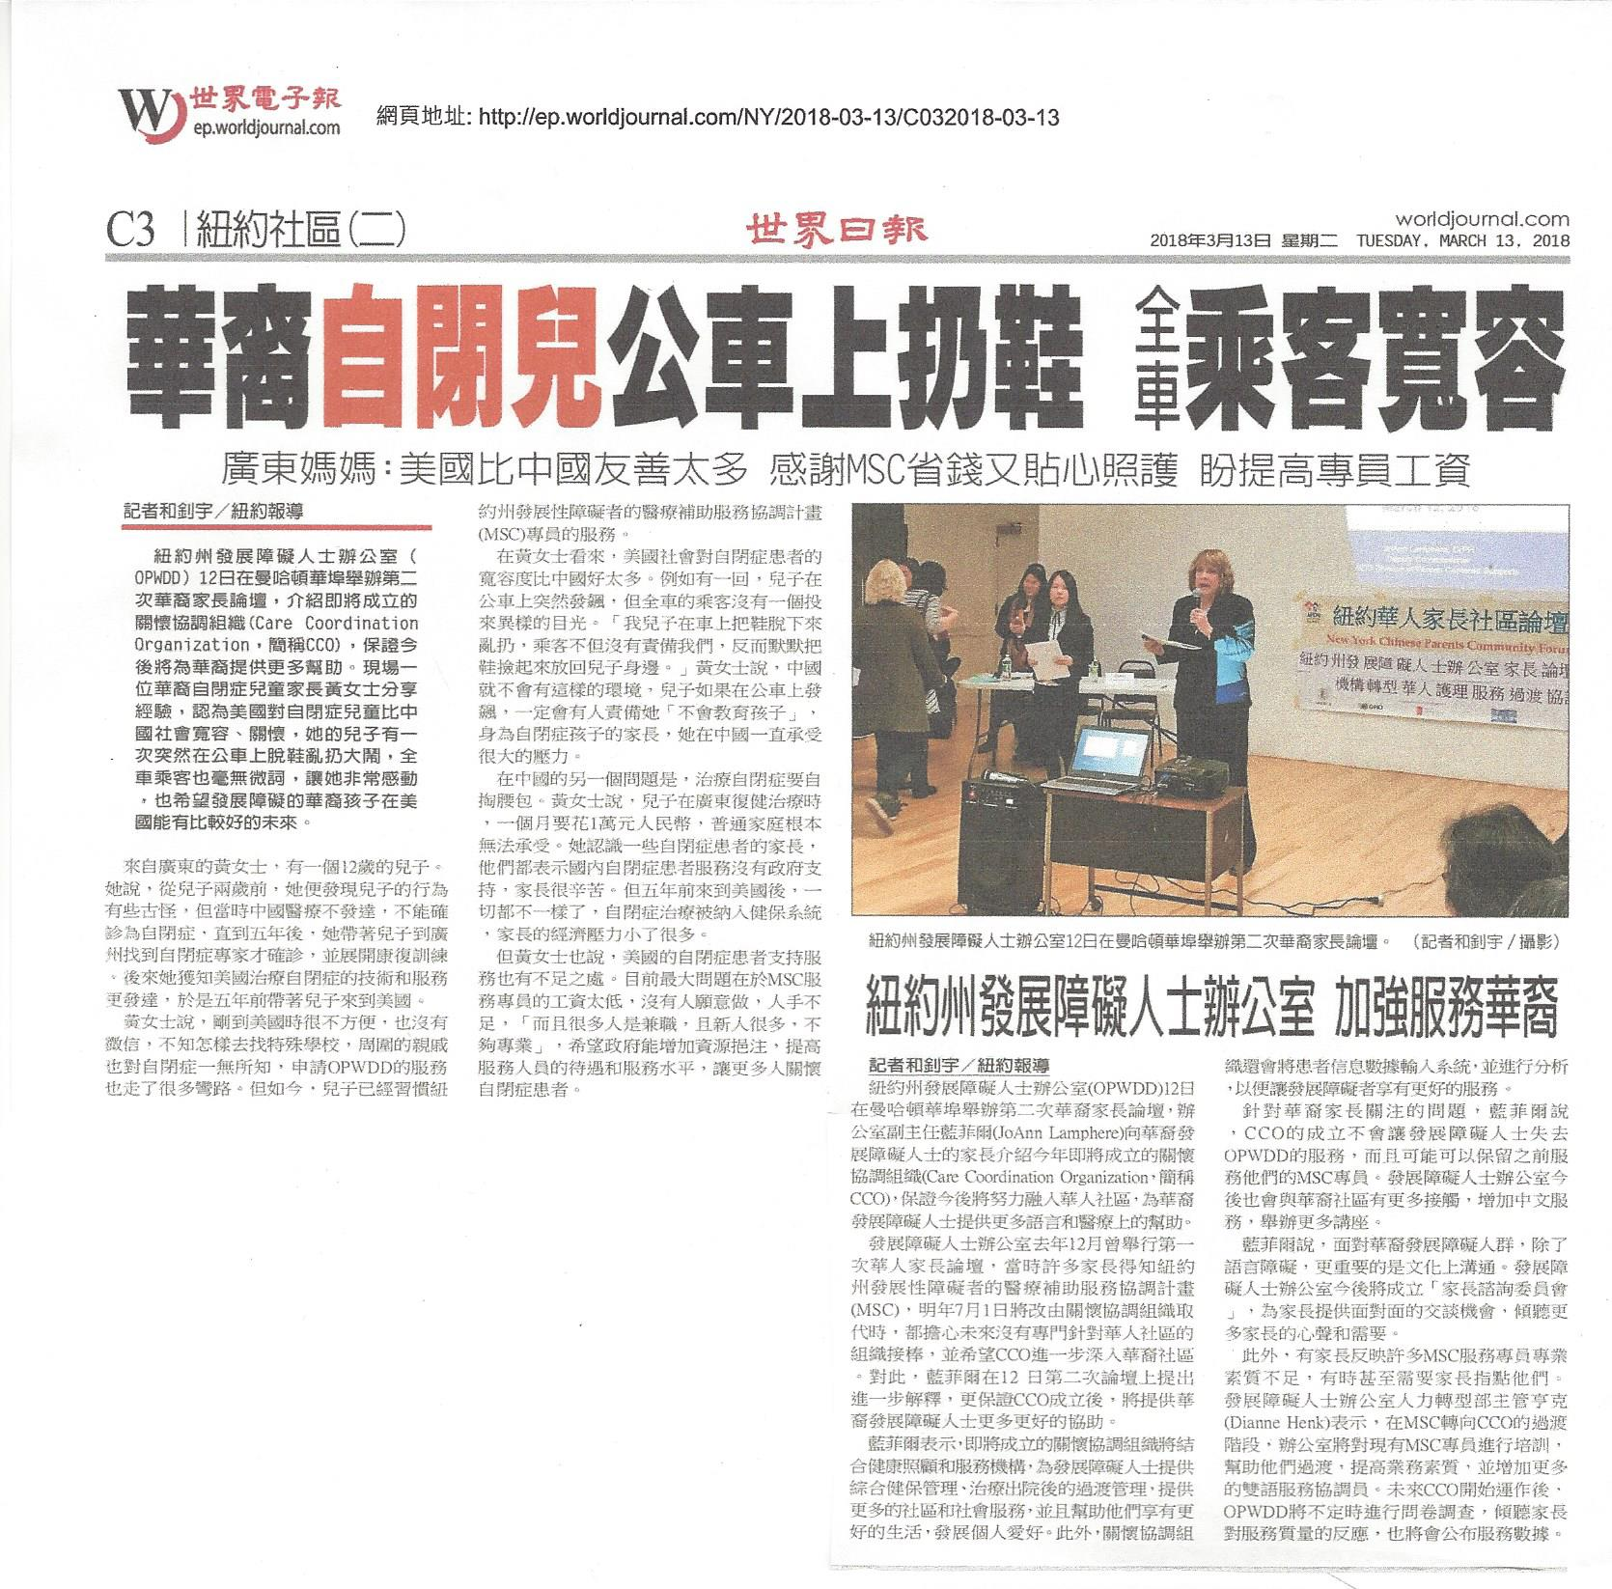

Tuesday, March 13, 2017

Headline:
OPWDD Forum – Chinese parents expressed their concerns on language barriers.

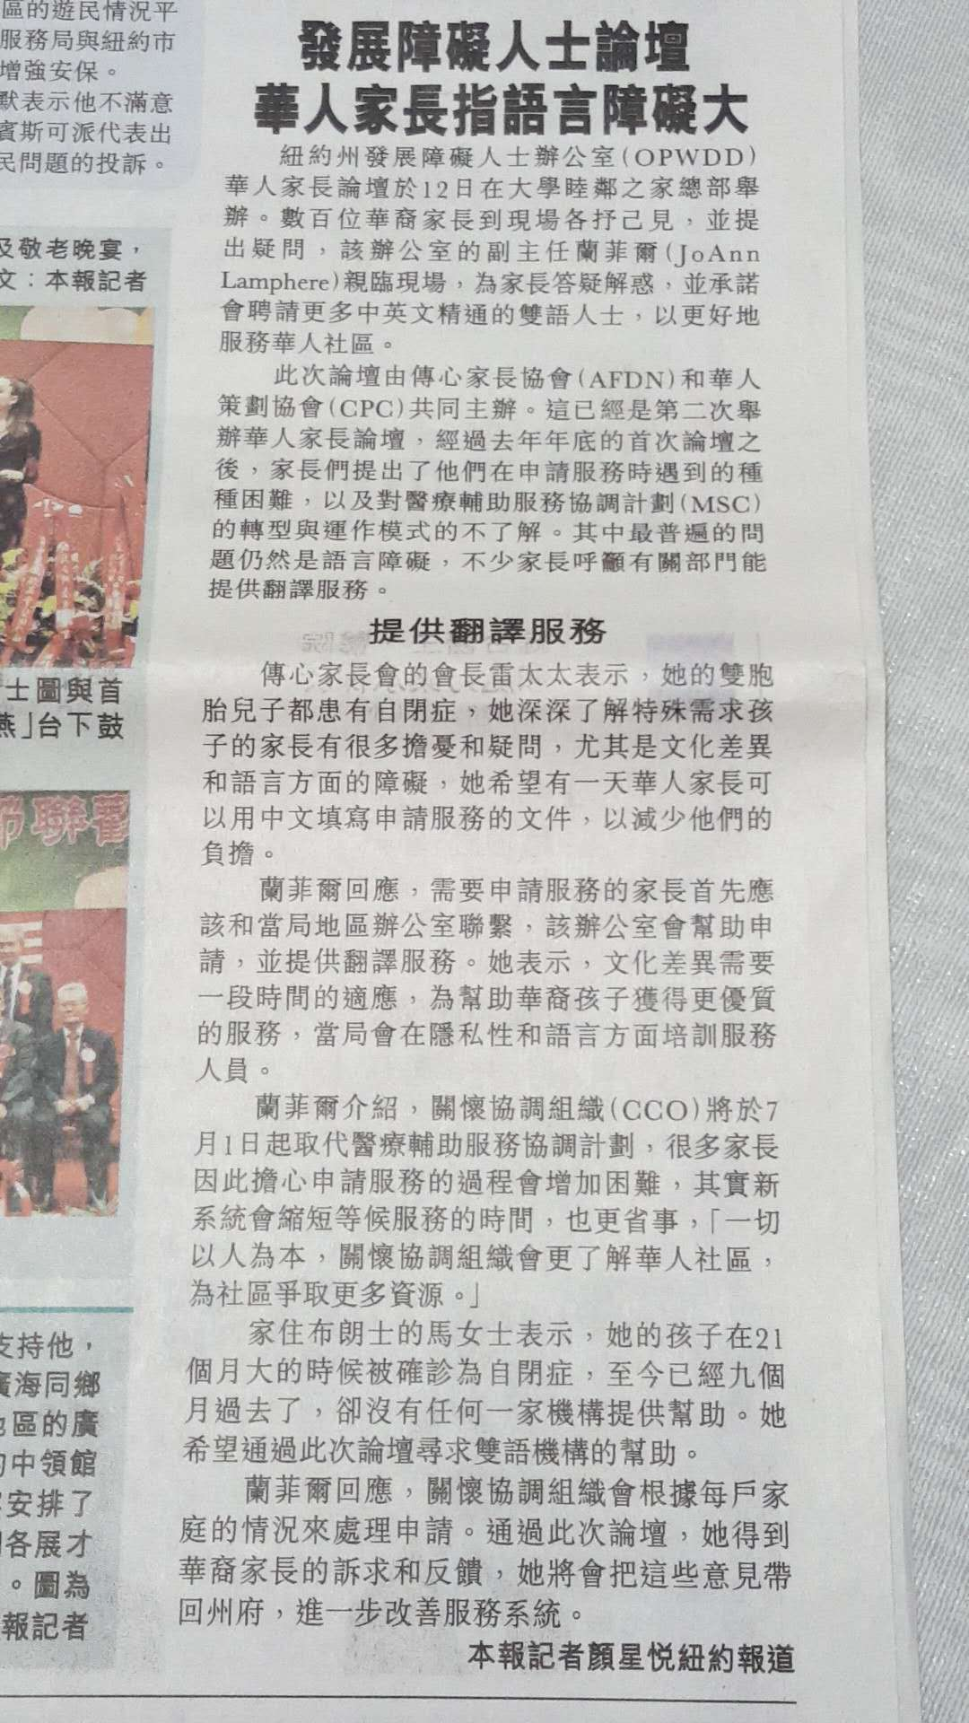

Tuesday March 13, 2018

Headline: No more MSC in the Chinese community. There will be great impact.

【侨报记者林菁3月12日纽约报道】纽约州残障局(Office for People with Development Disabilities, OPWDD)今年7月起将实行重大转型，一百多名华人家长12日与残障局官员进行对话，表达华人诉求，希望在华人社区设立服务办公室，以及提供中文语言服务。

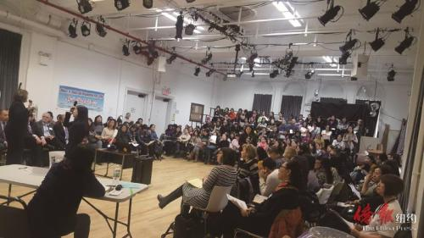
残障局官员与华人家长见面。(传心协会图)
华人社区MSC被取消 影响巨大

活动组织机构之一的传心家长协会会长叶玉蝉表示，纽约有一万多名有特殊需求的华人孩子，其中很多患自闭症。叶玉蝉说，残障局的转型将对华人有很大影响，因为原来华人社区的中介协调人(MSC)被取消了，全州用6个医疗协调机构(CCO, Care Coordination Organization)来取代，华人家长担心今后要直接跟新的大机构打交道，后者未必能在在语言和文化上提供相应服务。
残障局副局长兰菲尔(Joann Lamphere)和两名CCO负责人12日与华人家长见面，听取了家长的诉求。这是兰菲尔自从去年12月以来第二次与华人见面。华人家长表示，虽然残障局官员没有对华人的诉求给出明确答复，但州府奥本尼的官员专门到社区来，这是很好的对话，希望残障局听取意见后，对新的服务模式进行改善。
叶玉蝉表示，以前华策会有MSC服务，协助家长申请残障局服务，包括准备申请表等。改革之后，所有MSC都取消了，6个CCO中有3个在纽约市提供服务。华人家长中有懂英文的，也有不懂英文的新移民，他们希望打电话到CCO时有懂中文的人接听，也希望CCO设立亚裔部门，或在华人社区设立办公室。对此残障局官员没有做出具体承诺。
残障局改革之后，对原先的服务构架进行整合，由6个CCO统一服务，再由它们跟90多个机构签合同承包服务。华人家长表示，没有一个CCO是华人机构，这是意料之中的，因此也谈不上失望。
家长还提出，残障局的资料虽然有中文翻译，但翻译质量很差，有时候词不达意，希望改善。打电话时，虽然也有语言服务，但只是透过第三方的电话翻译，翻译员对一些残障术语不了解，造成了沟通的障碍。
March 13, 2018

Themes:
Services for people with ASD is in transition. New services start in July.
Six Care Coordination Organizations (CCOs) provide health coordinating services.
Noe of the CCOs are operated by Chinese.
The community advocate for open local offices in the Chinese traditional neighborhoods and hiring Chinese-speaking staff including receptionist.
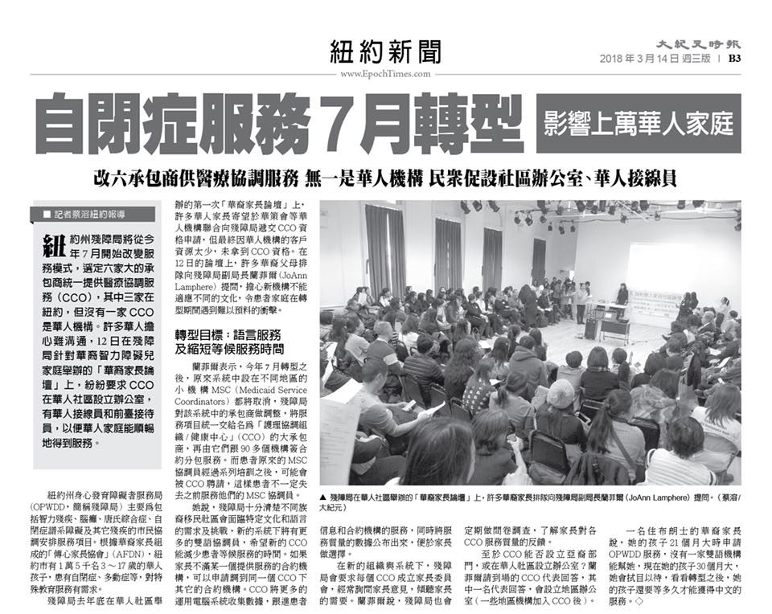

Appendix II
Selected Photos from Forum

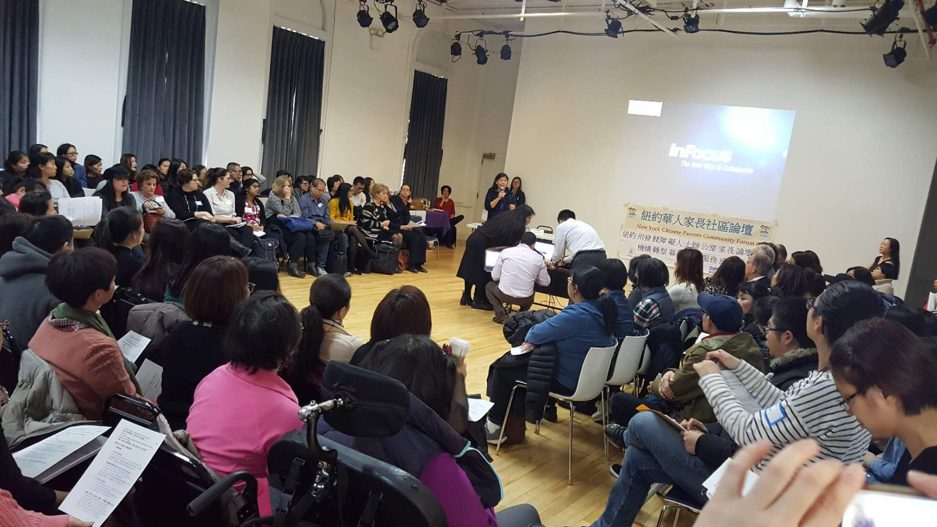
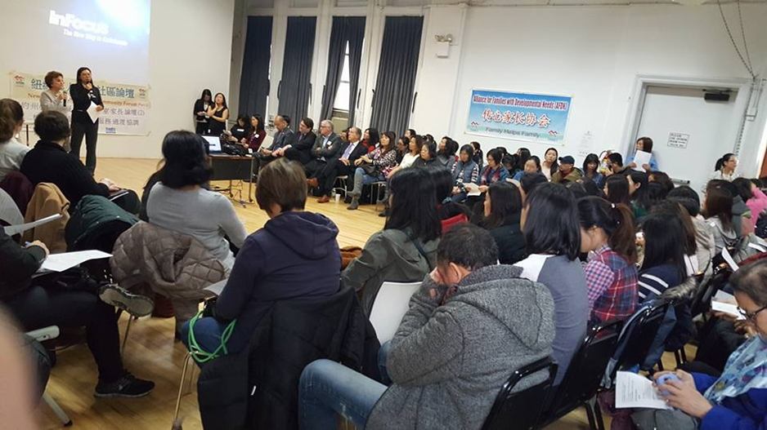
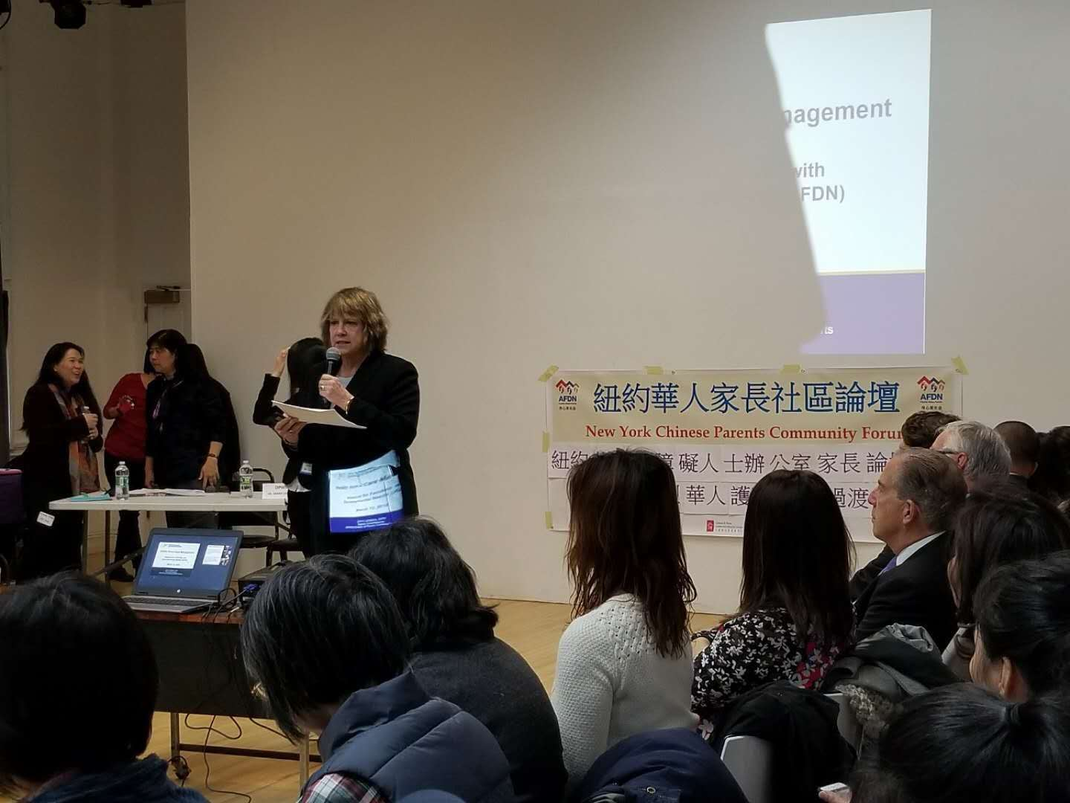

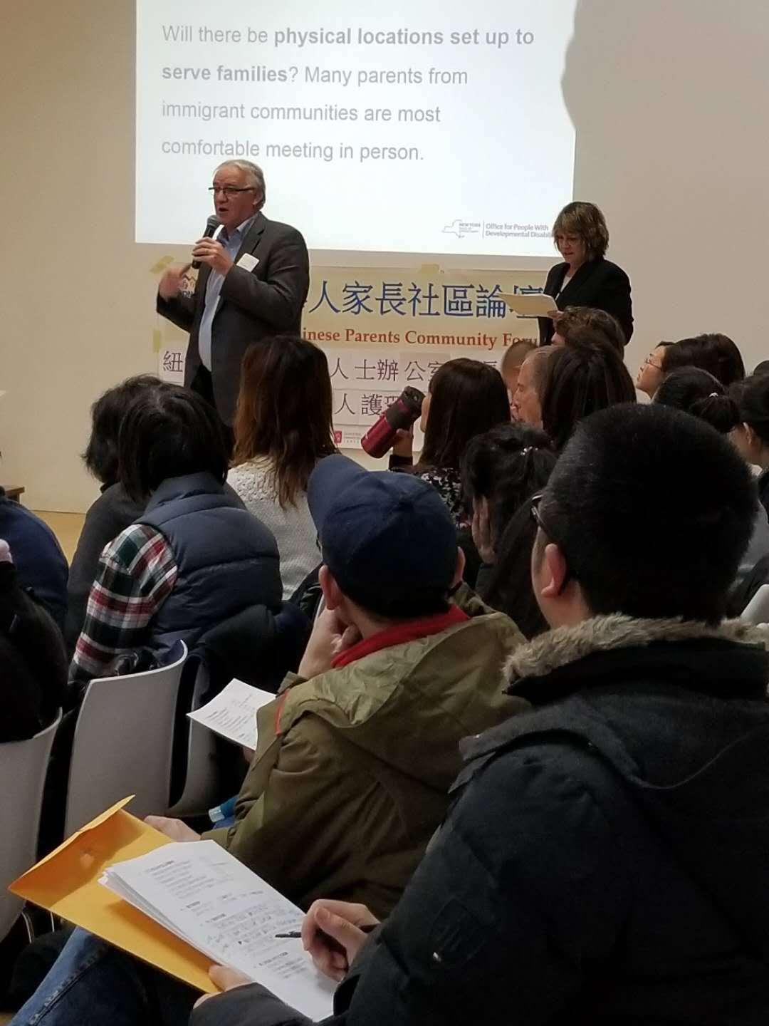
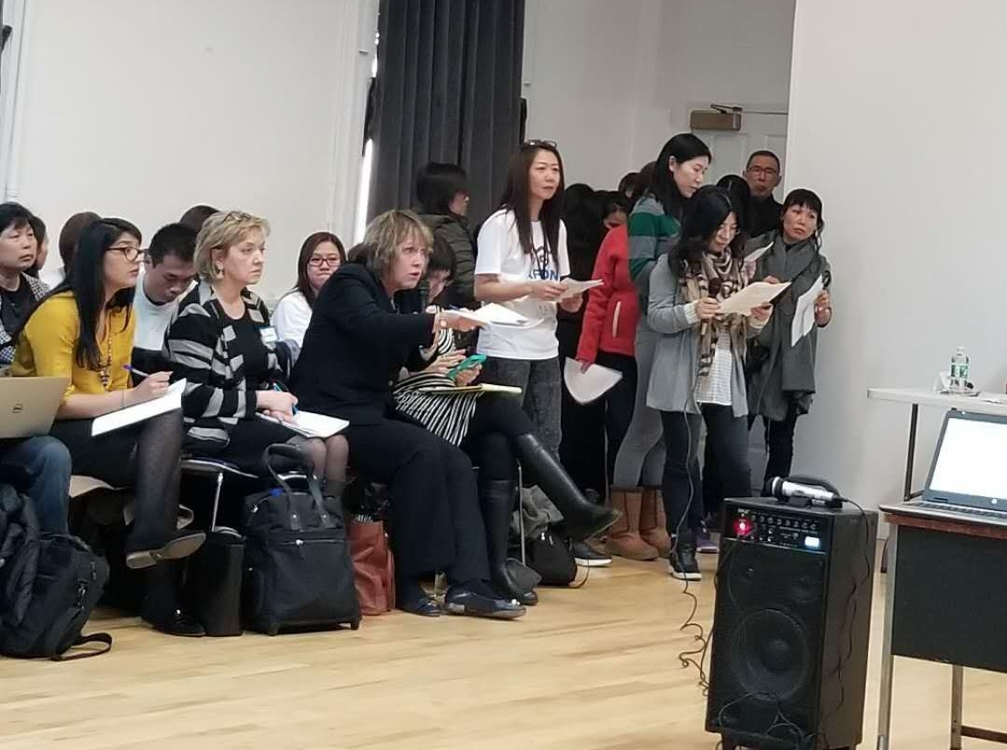

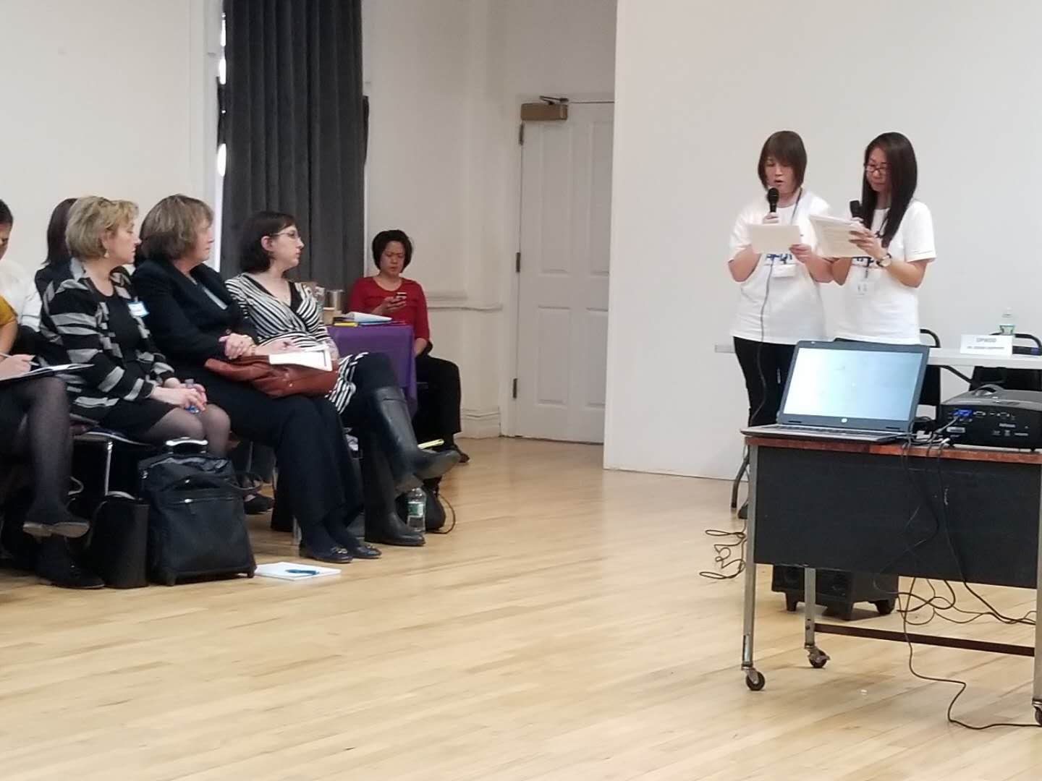

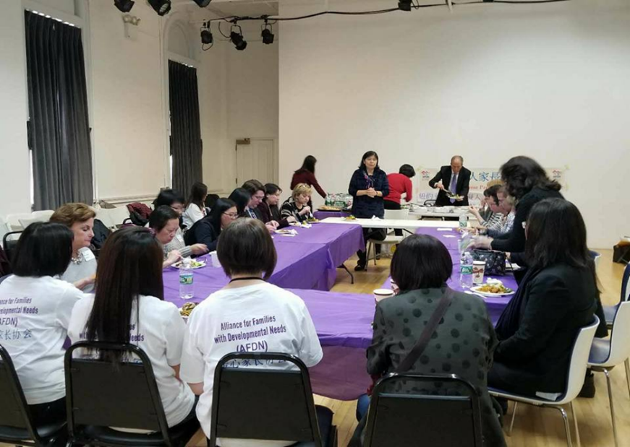

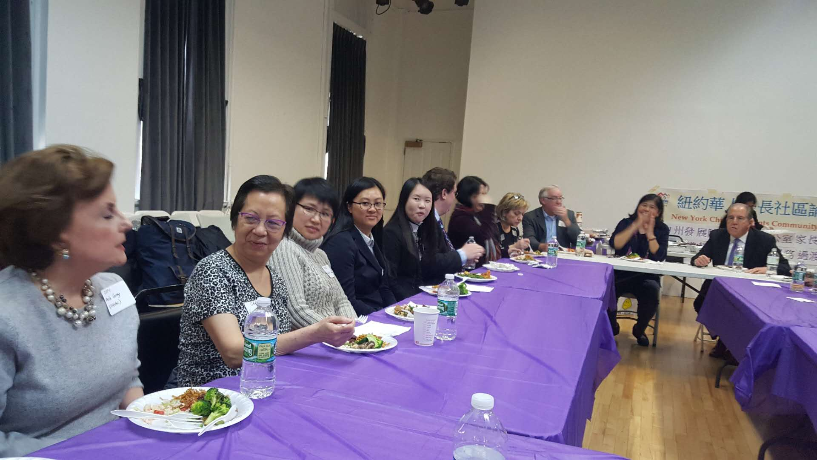
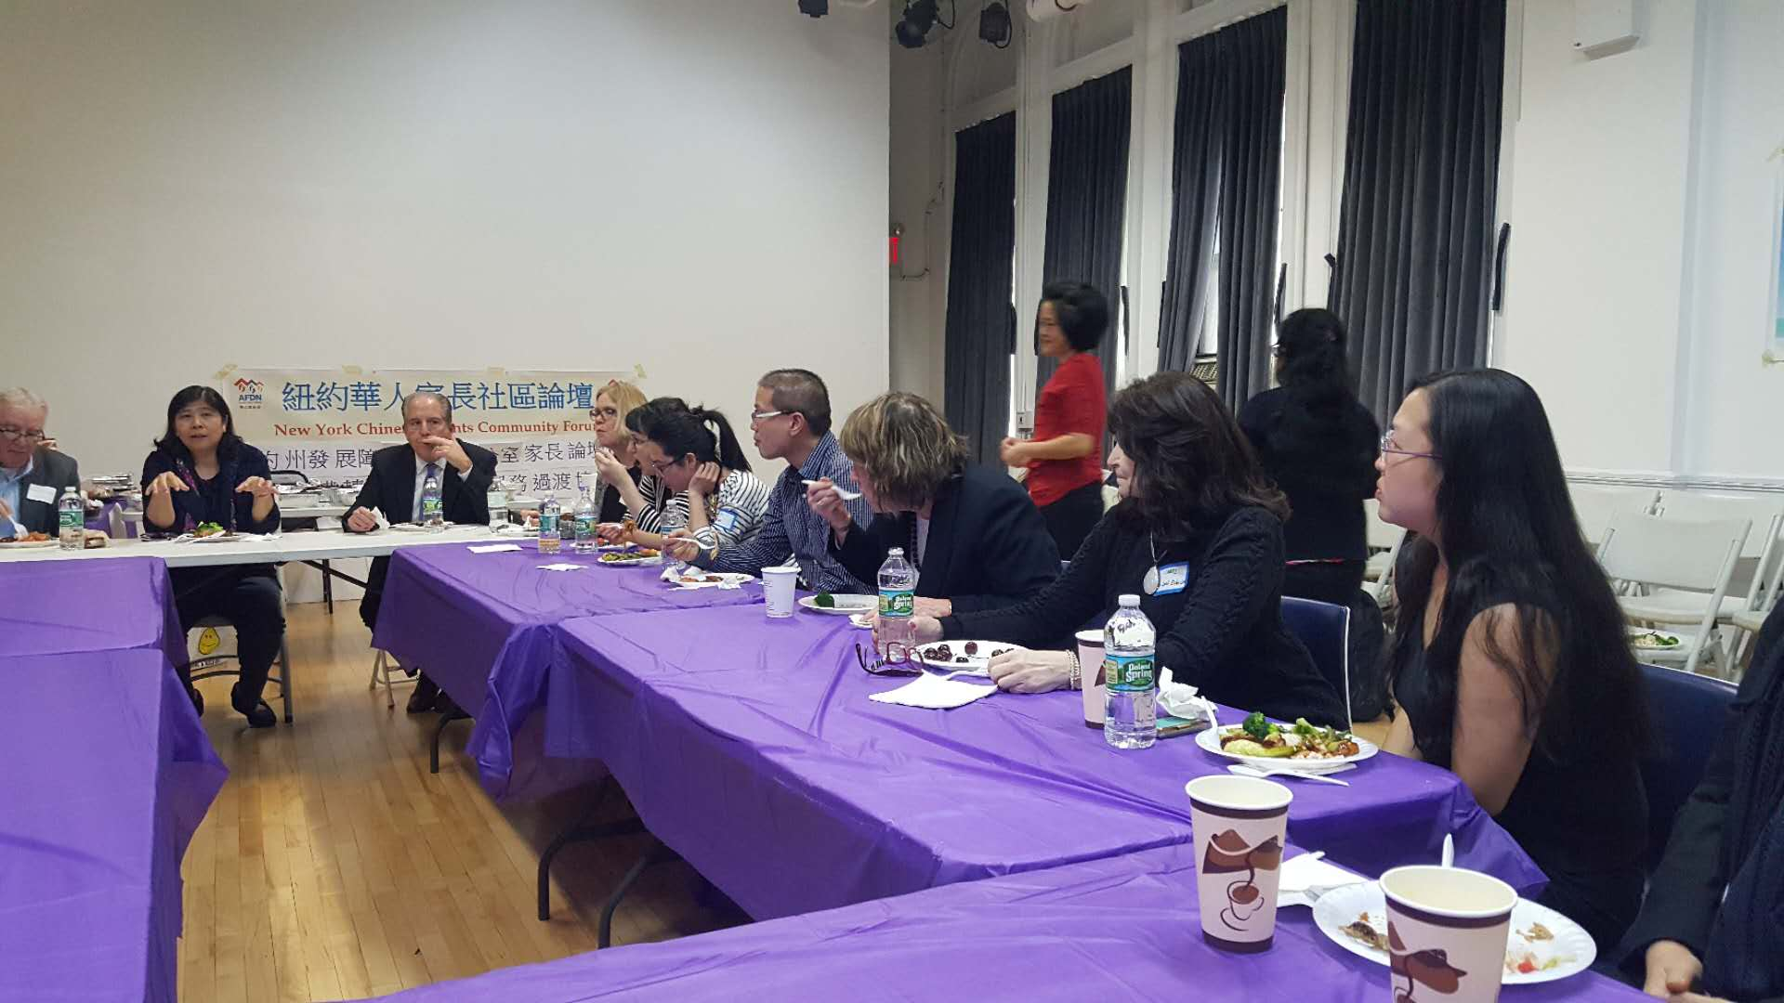

Appendix III

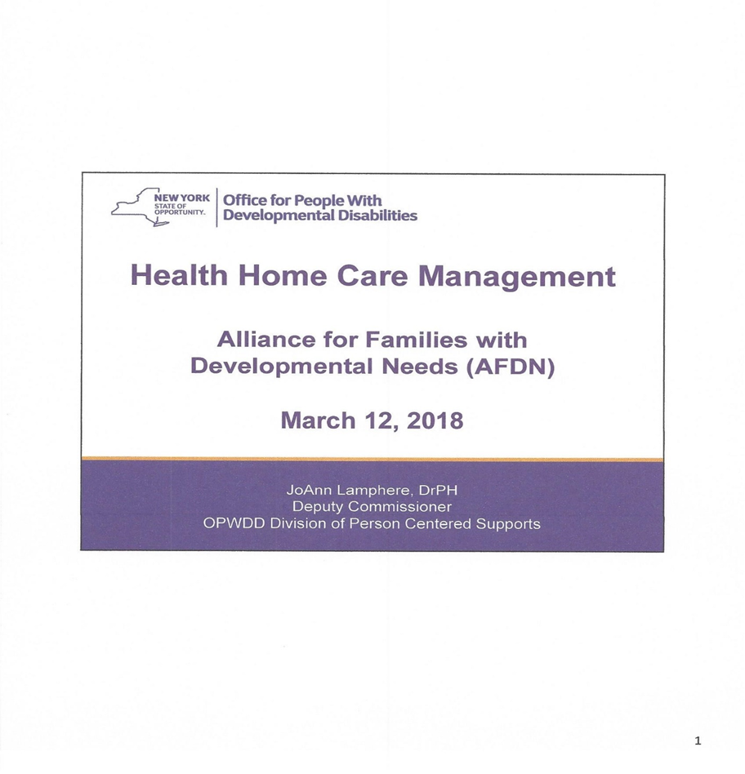
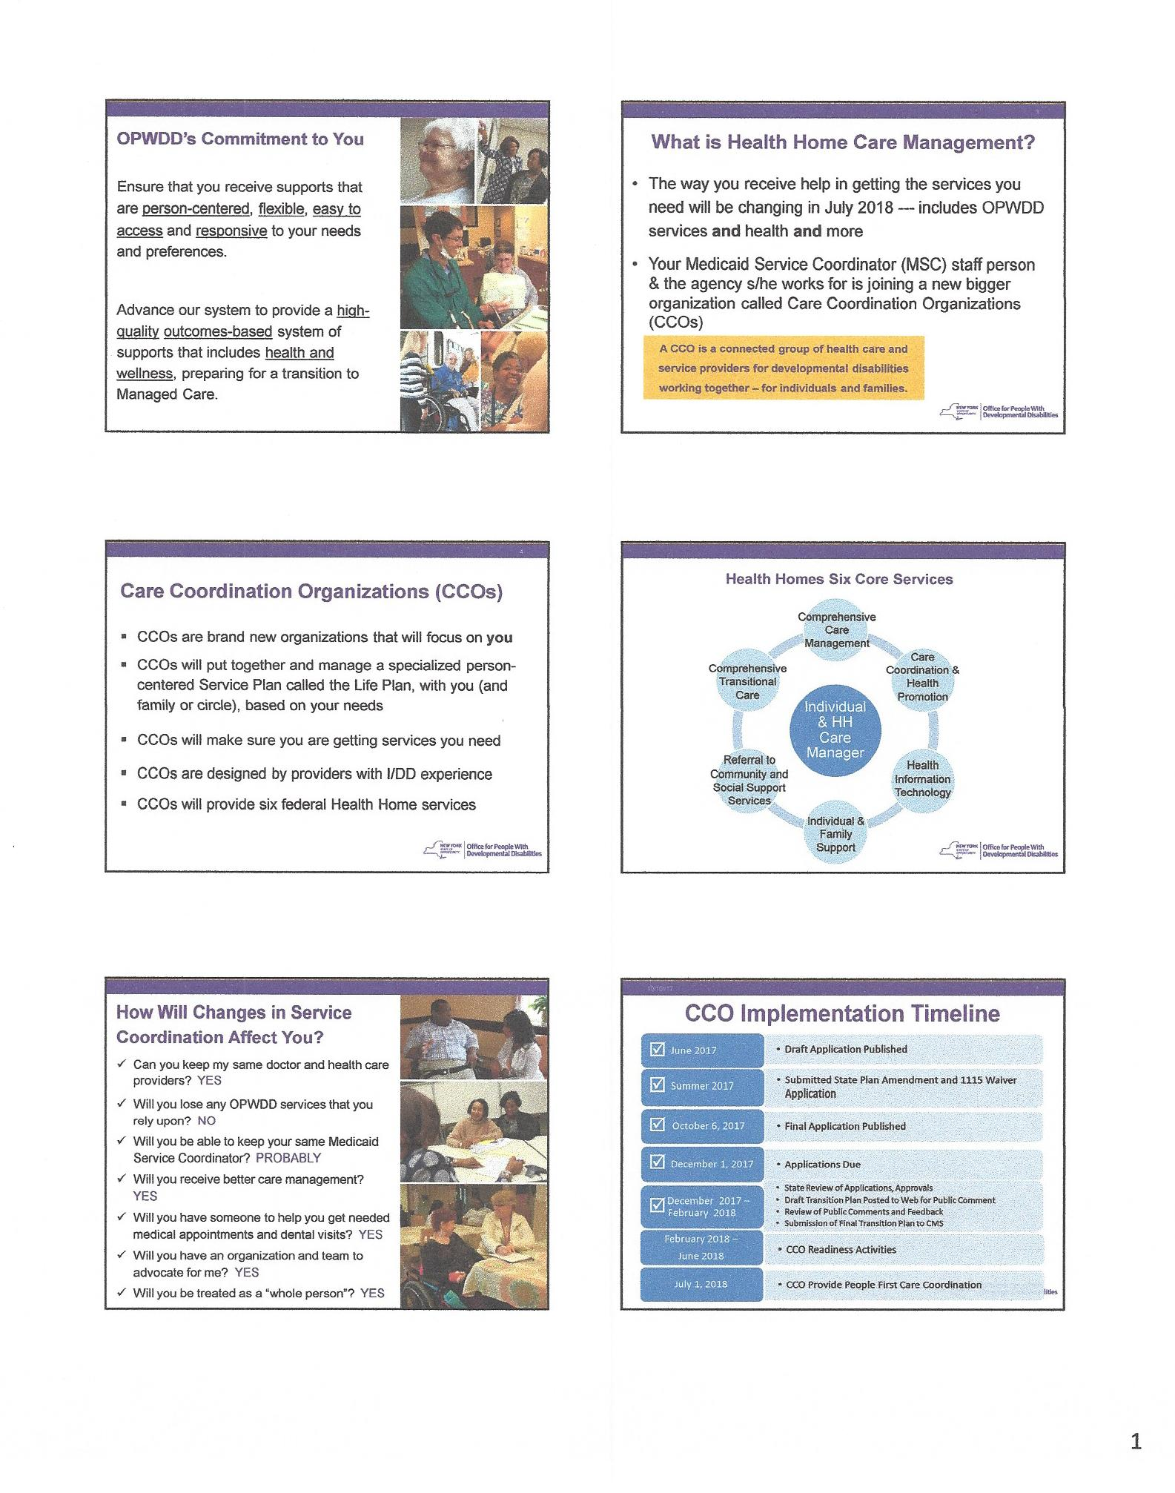
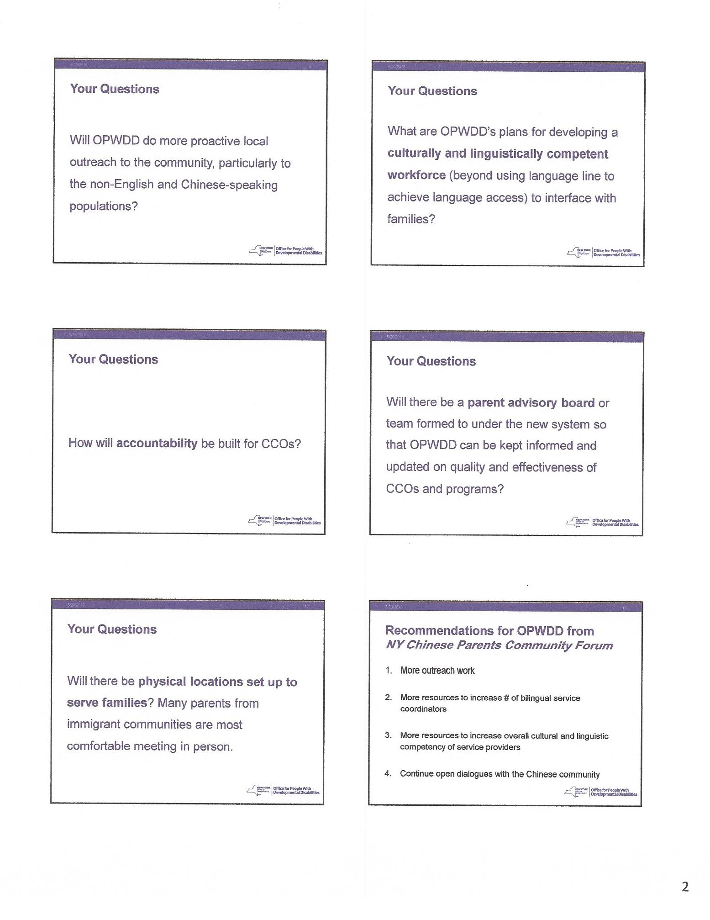
OPWDD Chinese Community Parents Forum (Part 2)
紐約州發展障礙人士 辦公室華人家長論壇 (二)
3/12/2018

Presenter: Dr. JoAnn Lamphere, Deputy Commissioner, Division of
Person Centered Supports at OPWDD
主講: 由紐約州發展障礙人士辦公室副局長(以人為本支援部)

講話內容幻燈投射片翻譯 (順序) [In the order of the PPT slides]
- 講話標題

- OPWDD的承诺
OPWDD致力于给您提供以您为中心的，灵活的，便利的和负责任的服务。
推進我們的系統，達到提供高質素並基於果效的支援系統， 包括健康与保健管理，準備過渡至管理式医疗照顧系統 (Managed Care)。

- 家庭健保管理系统(Healthcare Home Care Management )
1: 在今年7月以后,你从OPWDD到的服务将有改变。
2: 你现在的MSC和机构将会并入到一些大型的新的组织CCO (Care Coordination Organization, 管理协调組織)
[管理协调組織是一個把健康照顧和服務提供機構連接在一起的組織。這些服務發育障礙人士的機構為個人及他們的家庭一起工作。]

- CCO的业务范围:
1: CCO将负责管理以你为中心的服务项目,称为"生活计划(Life Plan)"
2: CCO将保证你得到所需的服务。
3: CCO的职员都具有丰富的智障和发育障碍的专业经验。
4: CCO将管理如下六个联邦健保计划

- 健康之家的六個核心服務 – 由健康之家照顧經理為個人提供的服務
综合健保管理(Comprehensive Care Management )
综合过渡管理(Comprehensive Transition care)
健保协调和健康促进(Care Coordination and Health Promotion)
推荐社区和社会服务(Referral to community and social support services)
健保信息技术(Healthcare Info Technology )
家庭及个人服务(Family and Individuals Support)
- CCO对你会有怎么的影响
1: 我能保留同样的医生和医疗服务吗? 答: 可以
2:我会失去任何OPWDD的服务吗? 答: 不会
3: 我能保留同一个MSC吗? 答: 或许可能,看情况而定。
4: 我会得到更好的服务吗? 答: 会的。
5: 你可以帮助我去看病和看牙医吗? 答: 可以
6: 你们可以为我们的权益呼吁和争取吗? 答: 会的
7: 你们会把我们当成一个"完整的人"来对待吗? 答: 会的。

- 推行時間表
2018年 2 月至6月 CCO籌備工作
2018年7 月1 日 CCO正式提供 “人本第一”的照顧协调服務

- "传心"提供的问题
1: 你们准备更多地接触社区,尤其是非英语和华裔社区吗?
- 2: 你们可以提供更多的适合少数民族文化习惯和语言的社区服务吗?
3: 你们怎么来建立起你们的可信度呢?
- 4: 你们会成立"家长咨询委员会"来更多地倾听家长的心声和需要吗?
- 5: 你们会设立更多的办公室吗?华裔家长会更喜欢面对面地交谈

- 華人家長給OPWDD 的建議
- 更多外展工作
- 更多資源增加雙語服務協調員
- 更多資源增加整體适合我們文化語言能力的服務提供者
- 持續與華人社區公開對話

Appendix IV Lunch Meeting Participants’ List
Forum Coordinating Organizations and Community Agencies
AFDN (Alliance for Families with Developmental Needs)
Dr. Rhoda Wong (Forum Coordinator)
Nyuksiem Yap (President)
Angie Zahida Ahmed (Vice President)
Debbie Wai Ching Chan (Treasurer)
June Siew Ling Lum (Community Liaison)
Fiona Shu Huan Xu (General Administration Officer)
Katie Liu (Member)

CPC (Chinese Planning Council)
Michelle Liu (Program Director)
Susan Zheng (MSC)

Charles B. Wang Community Health Center
Dr. Angela Chan (Developmental Behavioral Pediatrician)
Dr. Sherry Huang (Pediatrician)

C.A.R.E.S
Dr. Leah Esther Lax (Program Director)
Lisa Louie (Program Supervisor)
Amanda Ye (Assistant Program Supervisor)
Jennifer Zhong (MSC Supervisor)
Yanmei Chen (Senior MSC)

GHO
Pat Liu (Family Support Coordinator)
Insil Choi-Wong (MSC supervisor)

University Settlement
Eva Wong (Director of Programs and Engagement)

Legal Services NYC
Amy Leipziger (Senior Staff Attorney)
Kathleen Dennin (Senior Staff Attorney)
Nelson Mar (Education Law Specialist and Coordinator Education Law Task Force,
Senior Staff Attorney)

GUESTS

NYS OPWDD
Dr. JoAnn Lamphere
Dianne Henk
Hirah Mir

NYS DDPC
Sheila Carey
Jackie Hayes
Jessica Pidgeon
Nabila Ibrahim

Advance Care Alliance (ACA)
Jay Nagy
Peter Pierri

Care Design NY
James Moran

