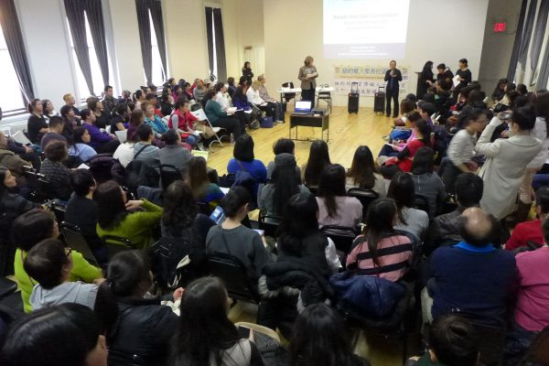

New York Chinese Parents Community Forum
  - OPWDD Services and Transition to
  - Care Coordination Organizations/Health Homes (CCO/HH)

  - Presenters:
  - Dr. JoAnn Lamphere, Deputy Commissioner,
  - Division of Person Centered Support at OPWDD
Ellen Bleckman, Community Service Administrator (CSA) at OPWDD

University Settlement Society of New York - Speyer Hall
New York City Chinatown
December 4, 2017
Table of Contents

- About the Forum
- Coordinating Parties
- Acknowledgement
- Agenda of the Forum
- Summary of Parents’ Questions and Feedback Part I
- Summary of Parents’ Questions and Feedback Part II
- Post-Forum Additional Questions and Feedback from Chinese Parents of Children with Developmental Disabilities
- Appendix I: AFDN Parents’ Letter to Deputy Commissioner
- Appendix II: Survey Findings and Statistics
- Appendix III: Press Coverage
- Appendix IV: Selected Photos from Forum

About the Forum

Background
According to CDC (2015), about 15% of children aged 3 through 17 years have at least one or more developmental disabilities. Based on this figure, an estimate of 18,750 children in Chinese families age between 3 and 17 living in New York City are potentially challenged with developmental and special education service needs.
Currently, approximately 1,200 children with developmental disabilities in Chinese families are being served by three OPWDD funded service coordination providers located in neighborhoods with dense Chinese populations. The existing service capacities are far away from the real needs in the community. Moreover, Chinese families encounter numerous problems in the process of applying, accessing and obtaining OPWDD funded and mainstream services due to cultural segregation and language barriers.
The announcement concerning transition of OPWDD from Medicaid Service Coordination (MSC) to Care Coordination Organizations/Health Home (CCOs/HH) has generated certain level of anxiety to Chinese families and caregivers of children with I/DDs. Many family caregivers are very confused about the changes in the new structure of service delivery. Then, they worry for losing the existing bilingual and cultural competent services provided in the Chinese focused community organizations.
Although OPWDD has organized several state-wide hearings and forums on transition to CCO/HH, Chinese family caregivers are compelled to stand outside the doors of these events. All these events were held in the evenings (4 to 6pm) and conducted only in English. Most Chinese parents and caregivers are primarily monolingual. They would not understand even if they participated in these events. In addition, parents and caregivers of young children would have difficulties attending evening activities in the community, after their children return home from schools. By that time, caregivers’ major roles are intensively to take care of their children with special needs.
The increase involvement of DDPC in the NY Chinese I/DD community in the past three years has facilitated and enhanced the communications between our Chinese caregivers and state agencies. Through DDPC Diversity and Inclusion Program Specialist Ms. Hayes, OPWDD officials became aware of Chinese caregivers’ confusion on OPWDD transitions and their obstacles for not able to attend any hearings/forums. In mid-November 2017, OPWDD has confirmed with our Chinese I/DD community that Dr. JoAnn Lamphere, Deputy Commissioner of the Division of Person Centered Support will come to meet our Chinese parents in NYC on December 4.
Purposes of the Forum
- Chinese parents will:
- increase Chinese parents’ knowledge on OPWDD services.
- increase knowledge on the existing services directly related to families and people with developmental disabilities in non-English speaking communities
- increase understanding on the OPWDD transition to Care Coordination Organizations/Health Homes (CCOs/HH).
- increase understanding on the impacts on families and people with developmental disabilities.

- OPWDD officials will have more understanding on:
- problems and obstacles in applying, accessing and obtaining OPWDD funded services.
- problems and obstacles in obtaining cultural competent services due to cultural segregation and language barriers.
- gaps between service capacities and real needs of the Chinese I/DD community.
- worries and uncertainties for losing Chinese focused local service points in the after the transitions to CCOs/HH.

- This is the first but not the last dialogue between OPWDD and Chinese I/DD community.

Preparation
The parent group Alliance for Families with Developmental Needs (AFDN) was very enthusiastic about the forum. AFDN is a mutual support group that maintain a network of over 300 parents in NYC. The parent members had worked very hard to put this event together with the support from Chinese community organizations, including University Settlement, Charles B. Wang Community Health Clinic and Chinese-American Planning Council. Within two weeks, the parents and the working team have accomplished numerous and countless tasks. The day before the forum, there were 175 parents registered for the forum.

The Forum
The forum turned out a great success! Over 160 attendees were present in the forum. It was well-organized and participants were extremely focused in the presentations and the discussions.

Community Service Administrator Ms. Ellen Bleckman had clearly spoken about the existing OPWDD service delivery system. Deputy Commissioner Dr. Lamphere had given an account in details on the forthcoming structural changes of the OPWDD service delivery system. Both Ms. Bleckman and Dr. Lamphere seriously paid attentions and responded to parents who asked questions and feedback to the presentations.
Coordinating Parties
Lead Sponsor:
Alliance for Families with Developmental Needs (AFDN)

Co-Sponsors:
University Settlement Society of New York
Charles B. Wang Community Health Center
Chinese American Planning Council Queens Community Services

Supporting Agencies:
C.A.R.E.S. NYC (Caring for Individuals with Special Needs and their Families)
GHO (General Human Outreach)

Acknowledgment
First and foremost, we would like to express our gratitude to Deputy Commissioner Dr. JoAnn Lamphere and NYC Administrator Ms. Ellen Bleckman for making the time to be present with us at the forum.
We would like to thank Sim Looi, President of AFDN, and AFDN committee members Angie Ng, Fiona Ho, Debbie Chan and June Lum for your passion, vision and leadership in organizing and mobilizing the hundreds of NYC caregivers.
We would like to thank Dr. Rhoda Wong for your tireless leadership, selflessness, incredible vision, wisdom, incomparable support night and day to ensure our caregivers’ voices in the community can be heard.
We would like to thank Ms. Eva Wong for your partnership, ongoing support to community caregivers and for handling the logistics of the forum, and University Settlement for hosting the forum on such short notice.
We would like to thank Dr. Sherry Huang and Dr. Angela Chan for your amazing support to parents in the community.
We would like to thank Ms. Dianne Henk, Director of Workforce Transformation at OPWDD for making important connections and ushering information to key contacts within OPWDD.
We would like to thank Dr. Jacqueline Hayes, Diversity and Inclusion Program Specialist of NYS DDPC for your tremendous continuous support to our caregivers and for facilitating communications throughout the planning of this forum.
We would like to thank C.A.R.E.S. NYC for providing knowledgeable staff for on-site interpretation at the forum.

Agenda of the Forum
- Welcoming
- Presentation Part I – Current OPWDD Service Provisions
Presenter: Ms. Ellen Bleckman, CSA, OPWDD
3. Parents’ Questions and Feedback
4. Presentation Part II – OPWDD Transition to CCOs/HH
Presenter: Dr. JoAnn Lamphere, Deputy Commissioner, OPWDD
5. Parents’ Questions and Feedback
6. AFDN Parents’ Letter to Deputy Commissioner
7. Conclusion

Summary of Parents’ Questions and Feedback
Part I
Ms. W, parent of child with Autism (Age 9)
My question has six parts:
- As a new immigrant, and a parent of a child with special needs, I am unfamiliar of the educational system in the United States. If I did not come in contact with Alliance for Families with Developmental Needs (AFDN), there was basically no channel for me to know about OPWDD. I believe there are more than a few other parents who are in the same boat as me, where our circumstances forces us to be in a disadvantaged situation, unable to actively pursue what we need to support our children (due to lack of knowledge). Therefore, I hope that OPWDD can partner with schools to allow parents with special needs children to receive your important information and resources.
- To ensure caregivers can clearly understand OPWDD, having a detailed handbook in Chinese that includes application procedures is necessary. This will not only mitigate confusions for parents, but will also reduce the workload of OPWDD personnel in having to address eligibility and application related questions.
- There is a very real and significant problem with the lack of cultural and linguistic service provider to families. Many parents like myself are very concerned about how this issue will be addressed and resolved.
- Some parents have shared the same observation as mine, where some service providers lack necessary professional knowledge. We suggest perhaps service providers ought to be provided with ongoing training. Furthermore, a staff person should undergo some type of assessment or qualification test prior to officially starting work to ensure quality of services and professionalism.
- Since the population of Chinese residents is ever-growing in New York State, parents with special needs children are in desperate need of Chinese linguistic services (both oral and written). For example, please provide pre-application inquiry related service in Chinese dialects (beyond using language line by phone) so that caregivers may more readily and directly communicate with service personnel.
- Many parents like me have shared that ABA therapy are very helpful and effective with their children but are puzzled as to why Straight Medicaid does not include this service.
Ms. S, parent of child with Autism (Age 14)
Parents are very concerned for the problem regarding the significant shortage of service providers. Is there any plan to ease this issue (what is this plan)?
- I myself and a large number of caregivers I know have observed and reported that some service providers (i.e. MSC) are lacking in professional knowledge. We would suggest that more professional in-service training be provided to these providers, and possibly for assessments to be implemented to ensure their professionalism and qualification. Based on my experience alone, my child has had many different MSC's, some are very professional and knowledgeable, while others have not been helpful whatsoever. For example, a previous MSC had helped me to apply for over-night respite for when parents need to travel. This June I requested for the same service and the new MSC had no knowledge of this service despite my daughter's record indicating this service from before. It has been close to six months and the MSC still does not know how or where to request this service. Why is this? Is it because there is a lack of support or supervision or training on their job? Fortunately, last week a DDRO staff provided home visit to us and turns out their department handles this request.

Ms. D, parent of child with Autism (Age 6)
My son was diagnosed autism when he was two and a half years old. After the early intervention program ended, I applied for OPWDD services for him. I waited for one year for MSC service. The first service that I applied for my son was community habilitation. I waited another 4 months for this service. I expected the worker would teach my child a little bit of life skills as I waited for such a long time (16 months total) to get this service. However, when I got this service, I found the worker didn't have any experience. She didn't teach my child anything and just watched him play by himself sometimes. As a result, my son did not gain any skills and his behavior problems even increased. I found another worker but it was the same result. I am ended up being very disappointed in this service. I hope OPWDD would consider the following:
- Provide high quality training to community habilitation workers.
- Time is very precious for young children with autism, especially before age 6. OPWDD should provide higher quality of services for families with young autistic children. Also, the applications for young children should be approved in a shorter period as most children do not get any services after early intervention program ends at 3 years old.
Ms. L, parent of child with Autism (Age 10)
With OPWDD, it is taking too long to obtain services for my son. Since receiving the determination of eligibility letter for my son, (February of 2016), it has been 2 years (excluding the time for doing all evaluations), and I am still waiting for respite services. During this process, there are many, many steps that a parent has to take, like going through Front Door, completing evaluation and being assigned an MSC, etc. There were also many obstacles to obtaining appropriate services. Some examples: I received Medicaid card for my son due to his disability but Medicaid Choice auto-assigned me to a managed care company (BCBS) which was not the right category in which to be enrolled. The MSC from 1st agency I used was supposed to handle the request to change back to straight Medicaid but didn't follow-up on a timely basis (for > 6 months) so I had to change to another MSC. Right after changing to the new MSC, I had to renew my Medicaid. The new MSC did take care of the problem and I got back to straight Medicaid but it took a while also (another 2 months). Then I had to renew the psychosocial evaluation (previous one expired after a year). Now, I have been approved for waiver service and respite, but I have been placed in the service provider's waiting list due to lack of staff. I have not started ANY service from OPWDD since approval 2 years ago. I just keep spending time contacting the MSC and renewing documents and evaluations with a lot of confusion and frustration with no end in sight.
Below is my timeline:
5/10/2016 I went through the Front Door, received Preliminary Individual Service
Plan (PISP)
5/27/2016 I selected & filled paperwork with MSC from 1st agency
8/12/2016 Medicaid application was approved, effective on 6/1/16
9/7/2016 I received letter stating my son was auto- assigned to managed care plan
(BCBS). I asked MSC to assist to change this without timely follow up
10/21/2016 OPWDD approved MSC program on 10/1/16
4/1/2017 I changed to another MSC with 2nd agency
4/17/2017 I received Individual Service Plan (ISP)
4/19/20017 I received Service Authorization letter for Wavier Service
6/1/2017 I dis-enrolled from BCBS
8/11/2017 MSC asked for Psychosocial Evaluation Renewal.
9/9/2017 I received letter & granted Medicaid Renewal, effective 6/1/2017
10/17/17 I submitted Individual Profile to apply In-home Respite to provider,
HeartShare

............. Now(12/4/17), my child is placed on waiting list for In-Home Respite.

Ms. H, parent of child with Autism (Age 12)
Many parents who are present today have the same question as me: Why does straight Medicaid not include ABA services? In reality, many caregivers of children with I/DD have attested to and experienced the extremely positive effect of ABA therapy on their children. I have personally experienced this also. From not knowing anything about the services or help for my child, to meeting other caregivers (through AFDN), I was introduced to a range of support services and interventions such as ABA therapy (AFDN caregivers also taught me how to apply for services and even including how to apply to OPWDD!).
As for ABA service, my child was approved for it through my insurance provider (namely Emblemhealth) in less than two months and he is qualified for 17 hours per week. It has been about a year since my child began receiving ABA therapy and the improvement in him is real and significant. This gives me reason to believe that other caregivers whose children have received ABA services also agree that their children had been helped greatly. (I am receiving this service through insurance – not OPWDD).
However, on the other hand, my child’s eligibility with OPWDD has just recently been confirmed after close to a year. However, I fear that as I proceed with OPWDD, I would lose this important resource of ABA services for my child.

Summary of Parents’ Questions and Feedback
Part II
Ms. P, parent of daughter with Autism (Age 17)

My daughter is 17 years old and we have been receiving MSC and other services from a Chinese-serving (Chinese governed) agency for many years, so we are familiar and comfortable with the services and processes there. If these agencies will no longer exist when OPWDD undergoes transformation in just a few months, what will happen to us? What will happen to my daughter and where will we go to seek help? I do speak some English but I do not thoroughly understand the complicated system of OPWDD. I am feeling overwhelmed and extremely worried about losing service providers who fully and profoundly understand the cultural and specific needs of my family. We desperately need these truly culturally competent service providers in the Chinese community to act as our bridge, advocate and help.
Ms. C, sibling of individual with DD
Even though I am speaking to you in English right now, it does not mean with my level of English proficiency, I can easily access all services that are needed for my sister with developmental disabilities. There really need to be a CCO that is run by people who have similar background (culturally) beyond the front-line staff level. There must be an in-depth understanding of our families’ needs and cultures beyond having a front-line staff member who simply speaks the language. Cultural competence is more than knowing how to speak Chinese. Having more translators or interpreters does not mean anything. Translators from interpretation services (e.g. language line) do not know our needs, they don’t know our family backgrounds, and is a one-time service that might feel no responsibility to care for the special, complex and sensitive needs of our family members.

Ms. O, parent

New York has a population with diverse cultural background. In 2010, the Asian population in New York City had exceeded a million, which makes up 13 % of the City’s total population. The Asian population had been vastly increasing in the last few years. Asian immigrant communities face unique cultural and language needs and challenges. I am not sure if OPWDD would grant an Asian focused Care Coordination Organization/Heath Home, according the proportion of the Asians in the total population.

Even though the non-Chinese speaking CCO/HH employs one or two Asian language speaking staff, that is never adequate in meeting the needs. Many Asian families need a group of providers equipped with considerable degree of cultural competencies. In turn, parents can directly communicate with the service providers. It is extremely important for families to obtain services from service providers overseen by agency and community leadership that actually have those specific cultural backgrounds.
Ms. G, parent of child with Autism (Age 5)
We hope that this forum will give us the opportunity to more deeply understand the future services for our children. We want to understand the upcoming changes and impact. Are these changes put in place to better serve our children with special needs? Will the services be more complete than under the current system? For example, how do we go about applying for services and what specific services will be covered? What documents should we caregivers prepare for our children to have eligibility (e.g. would Psychological and psychiatric assessment reports be sufficient?) What will the transition from MSC under current system to care coordination look like? What is the approximate length of time for transition and when will that begin specifically? Will the transition affect services we are receiving right now? Thank you.

Mr. A, parent of adolescent daughter with neuro-physiological needs (Age 18)
- I am aware of the OPWDD service delivery transformation to be carried out starting in July 2018. Has this change been finalized? Does the Federal government need to approve of this detailed plan? What if the Federal government does not approve?
- After the service change had taken place, what if I am unsatisfied with the CCO? Am I able to switch to another CCO?
- How will the quality and integrity of CCOs be monitored and guaranteed? What will accountability look like for these CCOs? I am hoping that culturally and linguistically competent staff will be hired to provide service to us. It is inadequate to rely on an interpreter or “language line” who has no background or knowledge about services related to developmental disabilities and our specific requests. I sincerely hope that staff people are able to empathize with us. For example, a good idea is for CCOs to prioritize hiring caregivers of children with I/DD.

Post-Forum Additional Questions and Feedback from Chinese Parents of Children with Developmental Disabilities
Ms. F, parent of child with Autism who is also hard of hearing (Age 17)
My child is deaf and has ASD. I am in need of sign-language service for my child. My son has been receiving MSC service for some time from an agency, but up to now, they have not been able to locate and identify service providers who also know sign language. Because of this, the progress and number of services my son can receive is limited. In turn, I have to be by his side often so that he can access help and services.

Ms. R, parent of child with Autism (Age 31)
Will all the I/DD participants currently under OPWDD need to be re-evaluated as we transition to the new system? If so, when will this process begin and which agencies will oversee these new programs?
I am also very interested to know how do we get to be a part of the parent team that get to monitor how these new programs are running especially for the initial 5 years to ensure quality and accountability?

Ms. M, parent of child with Autism (Age 11)
Under the new system, will there still be local offices with Chinese staff who can meet with us and help us with our needs?
I am asking this because I have experienced going to a government agency office (not OPWDD related) and having waited for more than 2 hours before finding out that they do not have a staff that speak my language and cannot help me. This is very frustrating and difficult.

Ms. G, parents of child with Autism (Age 5)
A lot of smaller agencies providing MSC services may not join or transition into being a part of a CCO, what will happen to the cases they are currently serving? Secondly, will the CCOs in reality have sufficient amount of case coordinators/case managers to handle existing cases?

Appendix I
AFDN Parents’ Letter to Deputy Commissioner
My name is Debbie Chan. I have a son age 15 having a diagnosis of ASD. He has been receiving OPWDD services for about 4 and half years.

I am a member of Alliance for Families with Developmental Needs (AFDN) and represent our group to speak here today. AFDN is a mutual support group for Chinese caregivers having children with developmental needs. We have a network of over 300 parents.

Today, we are delighted to have the OPWDD Deputy Commissioner Ms. JoAnn Lamphere to be with us. This is a valuable opportunity for our parents to share our experiences and express our concerns in the process of obtaining OPWDD services.

Similar to earlier feedback from other parents, we have also encountered numerous unpleasant experiences in navigating the OPWDD system.

  - First of all, there is no formal channel to learn about OPWDD services in the community. In my case, I have never heard about OPWDD in the first 7 years after my son was diagnosed with ASD at age 3. Until one day, I met a parent whose child attended the OPWDD-funded respite program.

Because of that, we recommend OPWWD would do more outreach work to introduce OPWDD services in the community. For example, OPWDD would outreach community providers, including public school support team, community health clinics, to organize workshops for parents and families having children with development disabilities. Our parents hope that OPWDD services will be more visible and transparent in the community.

  - Second, there is severely insufficient manpower servicing people with developmental disabilities and their families in the Chinese community. There is a limited number of Chinese-speaking and culturally competent workers. In our community, there are less than 30 Chinese-speaking MSCs providing services for about 1,200 people with developmental disability and families in three agencies providing cultural competent services. Now, some agencies have lost the capacity to take on new cases due to being overloaded. Even when parents obtain the TAB-ID, they are not able to find a Chinese-speaking MSCs to help coordinate their children’s services. This service capacity is far away from being sufficient to meet our real needs in the community.

Based on the vital statistics and census, we estimated that there are over 15,000 children between ages 3 and 17 who potentially have developmental and special education service needs in our community in a given year.

If these children are not in the OPWDD system, there must be a reason. Their parents may be unaware of OPWDD services because there is no formal channel to learn about OPWDD. Or, they have troubles getting into the system due to limited capacity or other barriers.

Moreover, direct services, including Comm Hab and Respite workers, are also inadequate, in terms of both quantity and quality. Many parents experienced long waiting time to get the services in place, even though they had obtained service approval from OPWDD. Then, when the direct service workers are in place, many of them only stay for a short period of time. Some of them only come once or twice and then disappear. Quality-wise, I believe these workers are mostly inexperienced and lack training. They do not understand the job nature very much.

We request that OPWDD would consider investing and putting in more resources to help the Chinese community to recruit, hire, and train more bi-lingual service coordinators and direct service providers. Moreover, we request that OPWDD would extend the measures to monitor community providers in recruiting quality workers and providing effective trainings to all level direct service workers.

  - Third, our parents worry that after the new transition to CCOs, we will lose our local service points in the community, particularly when the original service locations are phasing out in the local agencies. Now, these local agencies provide cultural competent services to our parents. We know where we can find them. The workers speak our languages, understand our unique socio-cultural dilemma and specific needs of the Chinese families.

As stated above, the current service capacity in Chinese community only covers about 1,200 recipients. It is very far from meeting our real needs in the community. Again, based on the vital statistics and census, we estimated that there are over 15,000 children between ages 3 and 17 potentially having developmental and special education service needs in a particular year.

We request that OPWDD would consider granting our community an independent cultural competent care coordination organization that the staff could understand our culture and needs. Chinese parents do have language barriers in getting services, but language and translations are not the only factor in fulfilling the goal of providing quality, touch-ground and culturally competent services to non-English speaking communities.

Lastly, AFDN requests that OPWDD will continue to have open dialogues with parents in our Chinese community.

Appendix II
Summary of Survey Findings on “Understanding OPWDD”
Date of data collection: 11/21/17
N = parents from 55 families

Q1 – Do you know what is OPWDD?
Yes = 44
No = 9
NR = 2
Provide one or more descriptions = 18
Give Chinese name of OPWDD 殘障局 | 13
An agency for children with DD | 1
An agency for DD providing required services to children with special needs | 2
Special services needed by children with DD. | 1
Helping children with special needs | 1
Issue ID for people with DD | 1
Providing services for people with DD | 1

Q2. Do you know what kinds of services OPWDD can provide to your child?
Yes = 36
No = 17
NR = 2
Provide one or more descriptions = 9
Provide services to special children that help parents to relieve stress | 1
Com-hab. | 1
Holiday/weekend respite | 2
Services for ASD | 1
Speech, OT, PT, | 2
Social skills training | 2
In-home services/trainings | 3
After school training | 1
vocational training | 1
home care | 2
MSC | 3

Q3. Do you know where you can apply for OPWDD services?
Yes = 45
No = 9
NR = 1
Provide one or more descriptions = 22
CPC/CPC helps to apply for MSC | 10
CARES | 4
GHO | 1
Front Door/FD & follow other process | 2
MSC | 1
Agency | 2
Request MSC application | 1
MSC helps to apply | 1

Q4. Do you know what is Front Door?
Yes = 38
No = 12
NR = 5
Provide one or more descriptions = 15

Pre-screening for eligibility determination | 1
The first step for OPWDD application | 1
That is the OPWDD agency | 1
Introduction to OPWDD services | 1
A seminar/a seminar about OPWDD/ a seminar to learn and understand OPWDD services | 4
Apply for OPWDD must go through the Front Door | 1
With the Front Door, one can apply for services | 3
With the Front Door, one can apply for extra services | 1
Obtain the eligibility letter | 1
Prior to OPWDD application, one must participate a face-to-face meeting. | 1

Q5. Do you know what is MSC (Medicaid Service Coordinator?)
Yes = 34
No = 18
NR = 3
Provide one or more descriptions = 10

Not sure MSC’s work | 1
Similar like a case worker to obtain services for your kids | 1
A worker helps my child to advocate for services in long-run. | 1
To help my child applying for benefits and services | 2
Health care service specialist | 1
To help people in OPWDD system applying services | 1
MSC’s help facilitates me to communicate with the school. | 1
Service coordinator | 1
Mediator | 1
Social worker | 1

Q6. Do you know what is “waiver”?
Yes = 26
No = 24
NR = 5
Provide one or more descriptions = 9

To have straight Medicaid for the child with income disregard, due to disability eligibility | 1
Regardless of family income, the child is eligible for services upon waiver is granted. | 1
Exempt from income eligibility criteria | 1
In-home training and holiday respite | 1
HCBS Waiver | 4
With Waiver, one can obtain services | 1

Q7. Do you know what is the TAB number? How is it related to services that your child receives?
Yes = 19
No = 31
NR = 5
Provide one or more descriptions = 8

Developmental disability eligibility letter | 1
Developmental disability eligibility letter number | 1
Record number | 1
Record ID | 3
Case number for each people in the OPWDD system | 1
Number for the child | 1

Q8. Type(s) of your child’s developmental disabilities:
Types | frequencies
Autism/ASD | 40
Speech disorder | 4
Behavioral | 3
ADHD | 3
Learning Disability | 1
No response | 11

Q9a. Current OPWDD service recipient: 24
Parents’ responded: 7 [less than a year = 2, one year or above = 4, about 2 years = 2]
Parent #2 Started application in 2016, approved in July 2017
Parent #10 Started application in July 2017, approved in November 2017
Parent #13 Started application in 2015, approved in 2017
Parent # 16 Started application in 2015, approved in 2016
Parent # 26 Started application in 2014, approved in 2016
Parent # 32 Started application in 2016, approved in October 2017
Parent #36 Started application in June 2016, approved at the end of 2016

Q9b. Application in process: 14
Parents responded: 8
- started over 2 years ago = 1,
- started over a year ago =1,
- 6 months or above = 2,
- 3 to 6 months = 1
- 0 to 2 months = 1
- Unknown time = 2

Parent #3 Started in May 2017, parents had just had phone interview.
Parent # 5 Started in October 2017
Parent #7 Just finished front door phone interview
Parent #11 Started in August 2017, pending waiver
Parent #14 Undergoing assessment
Parent #23 Started in the beginning of 2017
Parent # 28 Started in 2016
Parent # 41 Started in May 2015, received phone call in July 2017.

9c. Parents have not applied for OPWDD services at this time: 15
Parent #4 Will start the application soon.
Parent #51 Had not started yet.

Q10. Where do you obtain information about OPWDD services for your child?
Types | frequencies
School | 10
Pediatrics | 6
OPWDD/other state agencies | 6
Community/social Service organizations | 25
Friends and relatives | 10

Q11. Problems parents encountered when they apply for OPWDD services: 19 parents responded
MSC caseloads are too big.  Each MSC has too many cases of children with special needs – overloaded.  They are not able to attend to all needs and services of each child. | 1
Application process is too long.  I waited the Front Door phone call for 2 years. Too long. I have to wait and wait in each step. | 11
Services are not available, although they were approved  OPWDD was approved, but no professional services come to home  There are difficulties to get the services to meet the child’s needs. | 3
Language barriers: Parent does not know English, or Poor English proficiency  There is no Chinese speaking MSC. | 3
Lack of knowledge to apply for OPWDD services, including eligibility and age criteria | 3
Took long time to find MSCs. I have been looking for MSC. There is no Chinese speaking MSC. | 2
The application process is too complicated. There are many difficulties, such as various assessments, physician’s report, etc. Too many documents are required. It took too long to get the results of the assessment. | 3
I live in the Bronx. Services provided for Chinese are only available in Manhattan and Queens. | 1

Q12. Opinions and expectation on OPWDD future changes: 16 parents responded
I have never heard about that. I don’t know what changes. I am not aware of the OPWDD future changes. | 5
Too little promotion about “OPWDD changes” in the community, particularly in our minority community. | 1
I heard that there will be changes, but I am not clear about what changes? | 1
I heard about MSC First Care | 2
Very few MSCs, overloaded. The workload of MSC is too heavy. Therefore, we could not receive pertinent services promptly. | 1
There are very little Chinese services, or without translations. Services provided in Chinese languages are inadequate. | 2
There are very few (Chinese speaking) MSCs. | 1
Services are not available in place to meet our needs. The children do not receive pertinent services. | 3
OPWDD to make clearer and explain more concrete services, particularly the ultimate services for the children | 1
OPWDD does not cover ABA. | 1
To address housing issues for special children | 1
I feel that my (Chinese speaking) MSC helps me and my family a lot in getting services for my child with special needs. I hope that the MSC position will be kept.  I heard that there will be no more MSC. I hope the MSC will not be canceled and continue to provide more help to our children. | 2
To simplify the application process, let children with special needs to receive the services more straight forward.  Hope that the new changes are made easier for parents to navigate the system | 2

Additional statistical information:

Based on Census Bureau Current Estimates Program
NYS population 2016: 19,745,289
[NYS Comptroller report 2016: People of Chinese descent made up the largest share of Asian New Yorkers (39 percent)]
NYC population 2016: 8,537,673

2016 American Community Survey
NYC population 2016 8,537,673
NYC Asian population 2016 1,205,911 (71% of all Asian New Yorkers)
NYC Chinese population 2016 590,340 (50% of total Asian population in NYC)

NYC Department of Health and Mental Health Vital statistics
2015
NYC Birth total 121,673
Birth to Chinese families 9,053 (7.4% of total birth, 2nd rank after
Dominicans 11,255)
Birth to mothers born in China 7,911 (2nd rank after Dominican Republic 8,039)
2014
NYC Birth total 122,084
Birth to Chinese families 9,438 (7.7 % of total birth, 2nd rank after
Dominicans 11,034)
Birth to mothers born in China 8,272 (1st rank higher than Dominican Republic
7,674)
2013
NYC Birth total 120,457
Birth to Chinese families 8,819 (7.3 % of total birth, 2nd rank after
Dominicans 10,828)
Birth to mothers born in China 7,728 (1st rank higher than Dominican
Republic 7,670)
2012
NYC Birth total 123,231
Birth to Chinese families 10,067 (8.2 % of total birth, 2nd rank after
Dominicans 11,145)
Birth to mothers born in China 8,787 (1st rank higher than
Dominican Republic 7,866)
2011
NYC Birth total 123,029
Birth to Chinese families 8786 (7.1 % of total birth, 2nd rank after
Dominicans 11,100)
Birth to mothers born in China 7,775 (2nd rank after Dominican Republic 7,805)
Based on the trend of births, there are over 125,000 children in Chinese families in NYC, ages 3 through 17 in a particular year.
- approximately 18,750 children are potentially having developmental and special education service needs. (15% of the total, see below)
- Within that cohort, over 1,800 Chinese children in NYC could potentially be identified with ASD.

According to CDC 2015, 1/6 or 15% of children aged 3 through 17 years have one or more developmental disabilities.

The ADDM Network (2014) found that about 1 in 68 children were identified with ASD based on tracking across multiple areas of the US. Almost half of children identified with ASD had average or above average intellectual ability.

Appendix III Press Coverage
Tuesday, December 5, 2017
Headline: (Top)
Chinese Children with Developmental Disabilities. Extremely in Need of Care Service Organizations

NYS transforms service delivery structure. Asian communities in fear of being neglected. In tears, parent pleads for a specially formed organization.
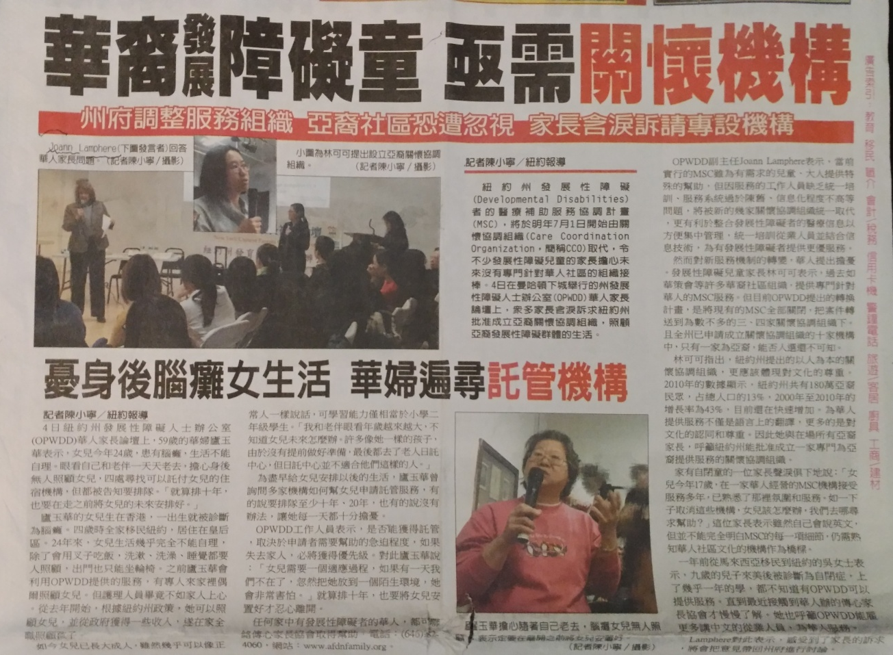
Sub-headline (mid-page):
Wearied of the care of her adult daughter with Cerebral Palsy when she passes away. Chinese mother has exhaustively searched for appropriate residential program.

Tuesday, December 5, 2017

Headline:
OPWDD Chinese Parents Forum
Chinese families advocate for a culturally competent Care Coordination Organization

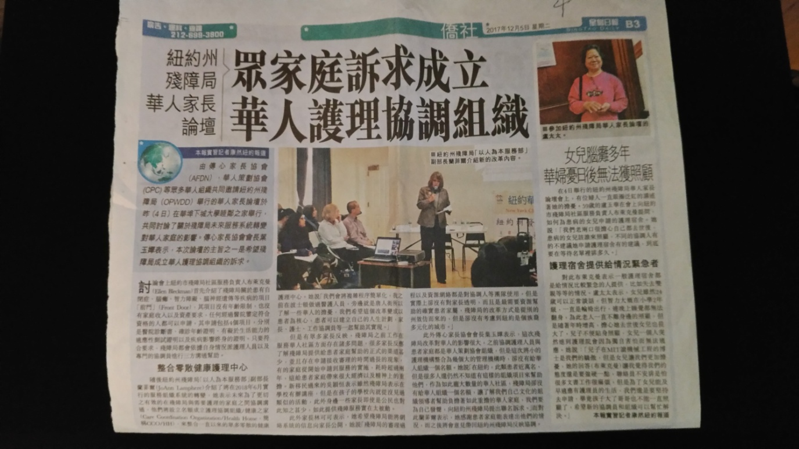

Tuesday December 5, 2017

Headline:
NYS OPWDD is in transition. Estimated more than ten thousand children with special needs in the Chinese community may lose access to services
Deputy Commissioner came to Chinatown to hear parents’ appeal

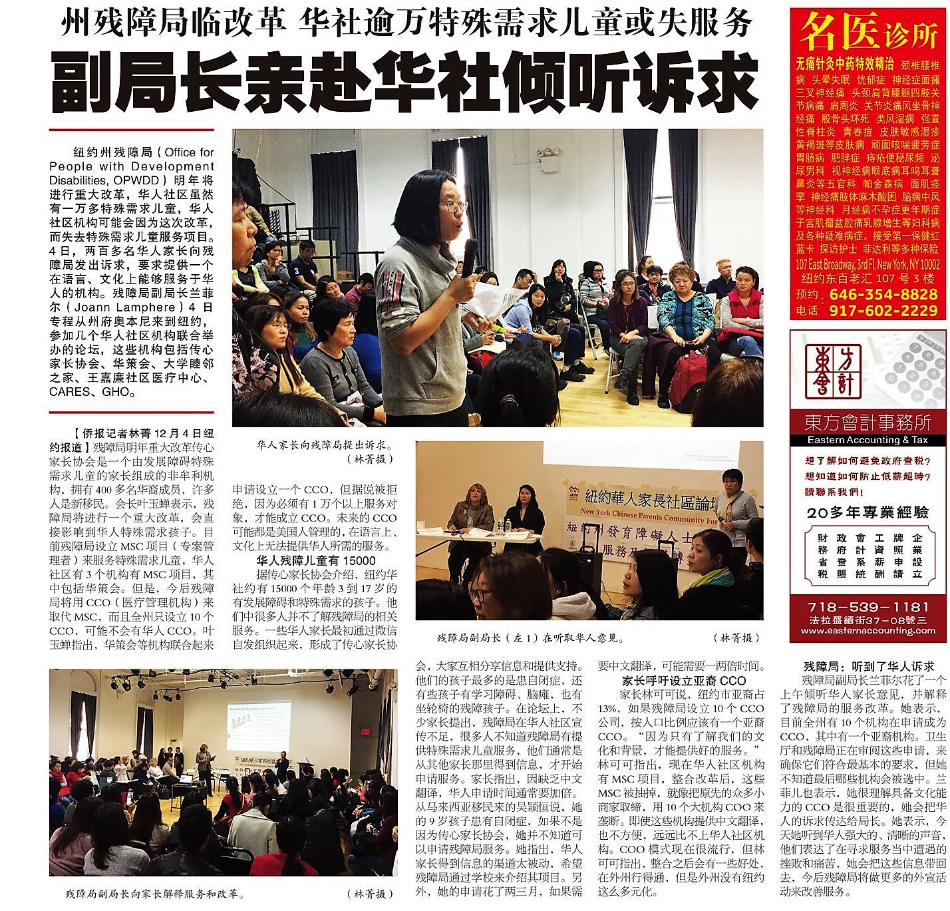

Headline:
Chinese parents worry about communication difficulties. Culture and language are obstacles to obtaining services for people with ASD in Mainstream CCOs.

Immigrated to United States with ASD son at age 9. Child only began to receive OPWDD services at age 14.

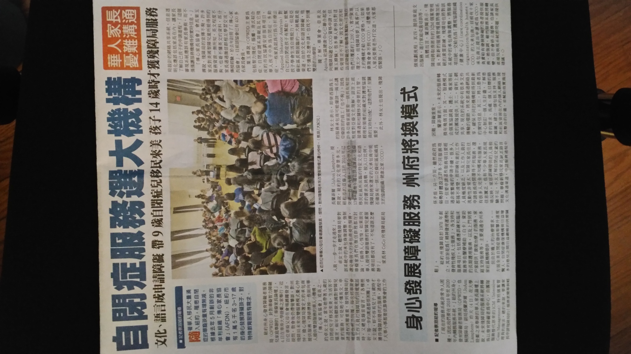

Television Clip: http://video.sinovision.net/?id=42152&sts=1512443136483&from=singlemessage

Tuesday, December 5, 2017

Headline:
Chinese parent of child with ASD blasts NYS government for disregarding the needs of Asian communities

Appendix IV
Selected Photos from Forum
